**Toward Development of a New Health Economic Evaluation Definition**

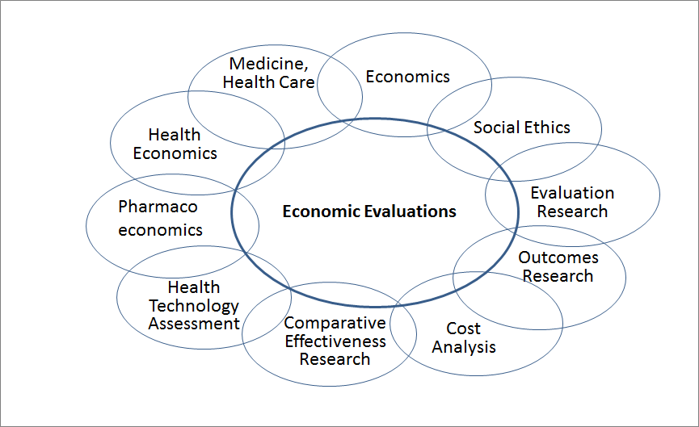

Figure 1. Economic evaluation lies on the intersection of subject areas of multiple sciences and fields of knowledge

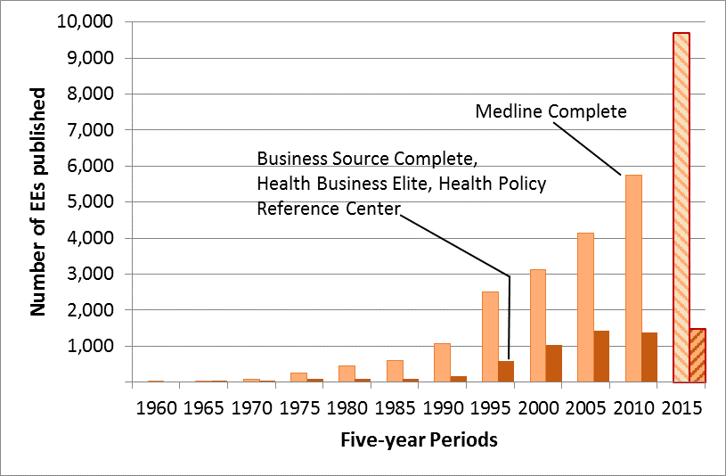

Figure 2. Historical dynamics of the EEs published in academic journals

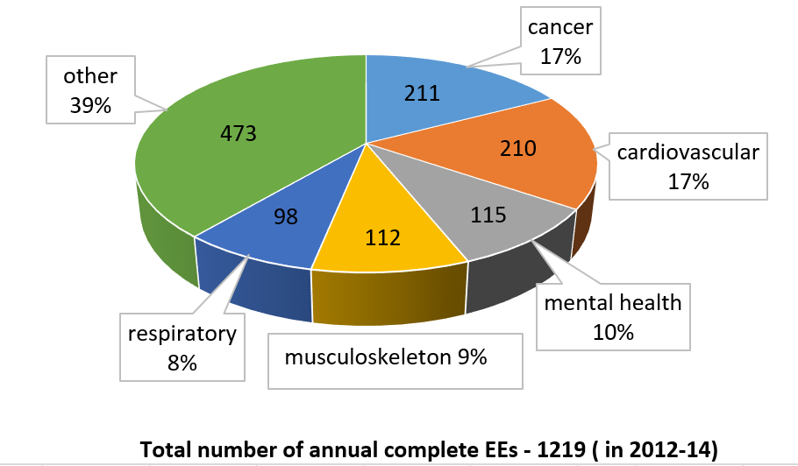

Figure 3. Annual number of EEs published in academic journals by health area