**Proliferation of Globalization and its Impact on Labor Markets in Advanced Industrial Nations and Developing Nations.**

**Proliferation of Globalization and its Impact on Labor Markets in Advanced Industrial Nations and Developing Nations.**

**Abstract**

The purpose of this paper is to provide insights into how the proliferation of globalization has impacted labor markets both in advanced industrialized nations and well as developing nations. Insightful analysis will be drawn from Oatley (2011) on division of labor, Jaumotte and Tytell (2007) on labor compensation, Hahn and Narjoko (2013) on the impact on South Asian Countries, Basu (2016) on wage as a share of GDP and Wallace, Gauchat and Fullerton (2011) on the impact of globalization and labor markets on inequality.

Keywords: Globalization, Labor Markets.

JEL Class: F66.

**1.Introduction**

Implicit in the term “globalization” rather than the older “internationalization “is the idea that we are moving beyond the era of growing ties between state and are beginning to contemplate something more than the existing conception of state sovereignty. But this change needs to be reflected in all levels of our thought, especially in our thinking of ethics and our political theory.

-Peter Singer, One World Now, Ethics of Globalization

The rate of globalization has increased at a phenomenal rate. During the past 50 years we have seen many governments that have progressively eliminated policy barriers to trade. The elimination of these barriers to has led to a decrease in both the transportation cost and the telecommunication cost. This fall in cost has consequently led to the creation of division of labor by making it cheaper to engage in import and export of inputs and organize and manage production on a global scale. Although there have been many benefits to globalization both for advanced economies and developing economies, there have also arisen problems. Hence, in last 15 years there has been a political backlash against globalization and critiques such as inequality, labor standards and the prioritization of commercial interests over others. Thus, the aim of this paper is to present findings of globalization with a focus on the labor markets and how globalization impacts the labor markets both in advanced industrial nations as well as developing nations. (Oatley 2011, p.357-358)

**2.Literature Review**

2.1The Globalizing World Economy and the Division of Labor

Following the standard international economic theory, we understand that an open international economy leads to the division of labor. Hence an opening up of borders allows international trade and allows the country to specialize in the intensive use of factors of production in which it is abundant in. According to Oatley (2011) such a division of labor is occurring in the global economy where, “each country produces goods in which it has a comparative advantage and sheds industries in which it has a comparative disadvantage.” Furthermore, there are four emerging tiers and these emerging tiers then have a consequent impact on the labor market.

Oatley’s (2011) study found the following:

* The advanced industrialized countries hold a comparative advantage in capital and human capital-intensive goods…
* The Asian NICs, especially South Korea, Taiwan, Hong Kong and Singapore hold a comparative advantage in mature and standardized capital-intensive goods…
* The second wave of NICs, including Indonesia, Malaysia, Thailand, Mexico and Argentina, hold a comparative advantage in labor-intensive goods such as apparel, footwear, and the assembly of finished goods from components.
* Other developing countries hold comparative advantages in land-intensive primary commodities such as fuel, minerals, and agricultural products.

Hahn and Narjoko (2011) in their study prepared for the Economic Research Institute for ASEAN and East Asia, provide us with a succinct definition of both globalization and labor markets. Hence, “Globalization in this study is broadly defined to include trade and foreign direct investment (FDI) liberalization, trade (exports and imports), international capital flows, outsourcing and traded intermediate goods while labor market outcomes are defined as wages and employment as well as volatility and dispersion of wages.” (p.v)

As mentioned earlier one of the main critiques of globalization has been the inequality of wages. Hahn and Narioko (2011) in their study utilize the two standard models of international trade, *Heckscher-Ohlin* (H-O) theory and the Stolpher-Samuelson theorem to explain the two theories that have been put forward for this critique which are: trade and skilled biased technological progress. Hence, “International trade is expected to increase the relative wages of the skilled worker in a skilled-abundant country while decreasing it in a skill-scarce country. An alternative explanation is due to an increase in relative demand for skilled workers because of improvement in technology.” (p.v)

The consensus that has been derived from earlier studies is that technological progress rather than trade which is the principal cause for the increase in the inequality. This point is further elaborated on by Basu (2016) who asserts that” the deep global shifts that I am referring to here have to do with technological change and the resultant changes in the nature of the global markets.” (p.657). Further analysis yields that wage inequality does not always occur as predicted by the HO-Model. Therefore, “While trade liberalization increases the wage inequality in skill abundant developed countries and decreases it in skill-scarce developing countries, wage inequality in practice rises not only in developed countries but also in middle-income developing countries.” (p.v)

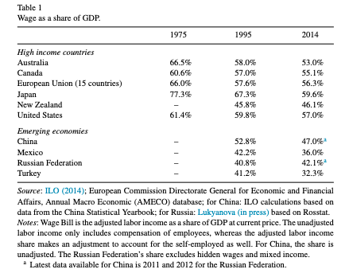

**Notes:** The table shows the decrease in wage as a share of GDP for both High Income Countries and Emerging Economies.

2.2 Impact on Advanced Industrial Countries

A study prepared by Jamoutte and Tytle(2007) for the IMF explains that it is natural to assume that, as the exports from developing countries and emerging markets are intensive in labor especially unskilled labor, that the integration occurring in the world economy would exert a downward pressure on the wages (corrected for productivity) of workers in advanced economies. Our above analysis and data from Basu (2016), reinforces this analysis. Although when we proceed with further analysis, we do find that the workers in advanced economies gain from trade. The main benefits occur due to enhanced productivity and trade, which is then termed, “(the size of the total pie) are larger than the negative effects on the share of this income that accrues to labor.”(p.8) There are large amounts of literature that document the gains from productivity suggesting that these gains may indeed be large enough in terms of productivity and reduction in the overall cost of production.

Furthermore, when we analyze labor compensation as compared to reduction in wage share, we find a considerable increase occurring from the 1980’s and a much more accelerated increase that occurred from the 1990’s. Hence according to Jaumotte and Tytle (2007), “This trend reflects both employment growth and increases in real compensation per worker, with a stronger weight on employment in the Anglo Saxon and on real compensation per worker in Europe.” (p. 9). The gains in trade have favored skilled labor then unskilled labor where the growth has been slower.

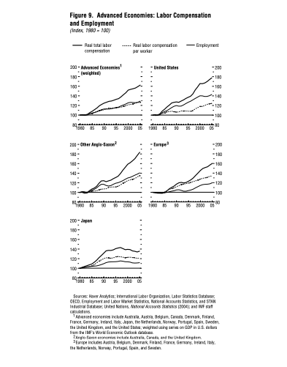

**Notes:** The graphical analysis shows the increase in labor compensation in advanced economies.

We see that our above presented analysis is of a historical nature representing a period from the 1980 to 2005. In more recent times there has been a renewed focus on research on the inequality especially in US. Wallace, Gauchat and Fullerton extend the earlier analysis from the 1980 and 1990 to present day times with a renewed focus on metropolitan level earnings. Their approach is quite novel forming a link between inequality, the dynamics of globalization and labor market transformation. Thus according to Wallace, Gauchat and Fullerrton (2011) “we examine the impact of five measures of globalization (global capital, foreign direct investment, exports, foreign born non-citizens, and foreign-born citizens) and six measure of labor market transformation (deindustrialization, corporate restructuring, bureaucratic burden, casualization, bad jobs, and multiple job holding) on metropolitan level earnings of inequality of full-time, full-year workers 16 years and older.”(p.1)

The study by Wallace, Gauchat and Fullerton (2011), produces some resounding results some in favor of globalization and some against. Hence, among the globalization factors that increase inequality are, “the presence of global capital, a large export sector and high number of foreign-born non-citizens increase inequality.” (p.17) On the other hand, factors that decrease inequality are, “high levels of foreign direct investment and foreign-born citizens.”(p.17) Thus, similarly for labor market transformation variables, “corporate restructuring, bureaucratic burden, casualization, and bad jobs increase inequality; deindustrialization has an unexpected but interpretable, negative effect on earnings inequality, and multiple job holding reduces earning inequality.”(p.17)

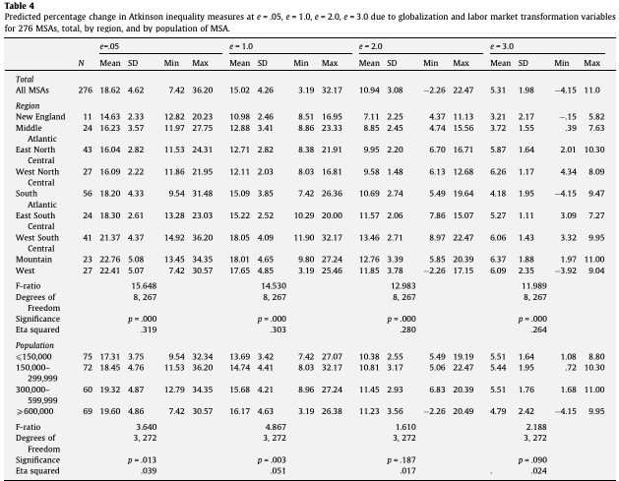

**Notes:** The table shows the impact on inequality due to globalization and labor market variables.

2.3 Impact on Developing Countries

Since there is an abundant of datum and research talent available in advanced industrial nations much of the analysis on the impact of globalization usually occurs for such nations. Although this is not to say the analysis for developing nations is not available, but the frequency of this research is lower. Hahn and Narjoko (2011), in their study prepared for the Economic Research Institute of Asean and East Asia, study the impact of globalization on labor markets with a particular focus on developing countries such as; Vietnam, Malaysia, Thailand and Philippines. Evidence from the studies show that, “premium wage affects labor market outcomes and wage inequality (between skill and unskilled workers) in the countries covered by research…Moreover, almost all of these evidences underline the importance of firm/plant characteristics in shaping the nature or direction of the impact.” (p.v)

Hence, the study yields the results that, “tariff cuts and increase in trade rise the wage premium in…technology intensive (Vietnamese study). Meanwhile, the wage premium exists in Malaysia between exporters and non-exporters.” (p.vi) Furthermore, a study in Thailand that examines the effects on engagement with international production networks and the reductions in tariffs on wage skill premium within firms yields the following results. “Engaging with production networks increases wage skill premium in skill-intensive firms while the tariff reduction is found to reduce the skill premium within firms.” (p.vi)

A contrasting study on Indonesia and Philippines yields interesting results in the opposite direction then that of Vietnam or Thailand. Hence globalization is seen to have, “somehow smoothened its adverse impact on labor market outcomes.” (p.vii) The study on Indonesia indicates that, “while there is evidence that firms pays higher wage for skilled workers, there is a declining pattern of relative (skilled to unskilled) workers over time.”(p.vii) Furthermore, the on Philippines yields the results that, “the premium of skilled workers in terms of wage (wage skill premium) is found to have declined over the time, and it is attributed to the decline in trade protection.”(p.vii)

It is quite normal to assume that globalization brings large benefits to developing countries especially in terms of wage convergence towards advance economies. Jaumotte and Tytell (2007) provide one of the earliest analysis on emerging market economies using data from the manufacturing sector. Their analysis indicates that there is indeed a convergence of wages particularly from Asia that have been converging towards those of the US. Asian countries which started developing earlier have seen a large amount of convergence. Hence, “Studies confirm that both trade and emigration have contributed to rising incomes of nationals of developing countries, although the evidence on their impact on inequality is mixed.” (p.7)

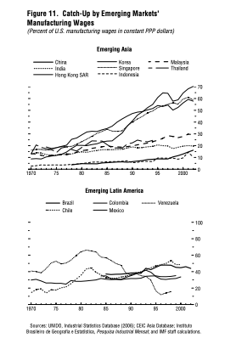

**Notes:** The graphical analysis shows the increase in labor compensation in emerging markets.

**3. Conclusion**

The review of relevant data and literature although not exhaustive provides us with sufficient evidence of the impact on labor markets due to globalization. Opening to international trade allows countries to engage in the division of labor and hence in specialization. We also see that opening to trade and globalization has led to the emergence of four tiers of nations, with each tier holding comparative advantage in the production of a specific good. Furthermore, we see that there has indeed been a significant impact on labor markets since globalization. There has been a decrease in the wage as a share of GDP in both high-income countries as well as emerging countries although this decrease has been accompanied by an increase in labor compensation. Further investigation has revealed that one of the main problems that have arisen due to globalization is inequality. A study focused on metropolitan areas has revealed the factors of globalization and labor markets that impact inequality.

# 

# References

Basu, K. (2016). Globalization of labor markets and the growth prospects of nations. *Journal of Policy Modeling*, 656-669. Basu, K. (2016).<https://doi.org/10.1016/j.jpolmod.2016.05.009>

Hahn, C. H., & Narjoko, D. A. (2013, March). *www.eria.org.* Retrieved from Economic Reserach Institute for ASEAN and East Asia: http://www.eria.org/

Jaumotte, F., & Tytell, I. (2007, December 1). *www.imf.org.* Retrieved from IMF: https://www.imf.org/en/Publications/WP/Issues/2016/12/31/How-Has-The-Globalization-of-Labor-Affected-the-Labor-Income-Share-in-Advanced-Countries-21520

Oatley, T. (2011). *International Policital Economy: Interests and Institutions in the Global Economy, Third Edition.* Pearson Education, Inc.

Wallace, M., Gauchat, G., & Fullerton, A. S. (2011). Globalization, labor market transformation, and metropolitan earnings inequality. *Social Science Research*, 15-36.https://doi.org/10.1177/0160449X13511539