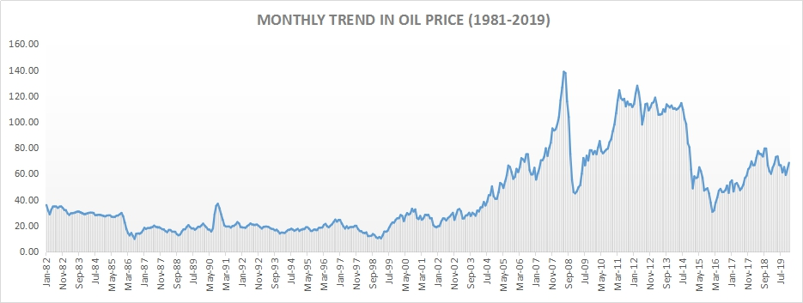
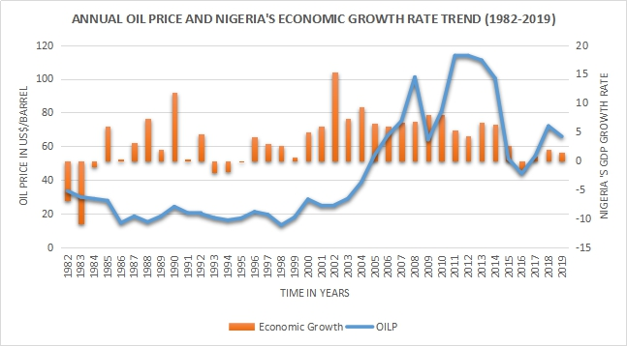

TABLE 1: Description and source of data
Variable | Full Name | Description | Source
OILP | Brent Oil Price | UK Brent Oil Price in US dollar per barrel | CBN Statistical Database
GDP | Nominal GDP | Nigeria GDP in billion Naira | WDI
INV | Investment Expenditure | INV proxied with gross fixed capital formation in billion naira. | WDI
EXPORT | Value of Nigeria’s Export | Value of Nigeria’s Export in local currency units. | WDI
IMPORT | Value of Nigeria’s Import | Value of Nigeria’s Import in local currency units. | WDI
INFR | Annual Inflation rate | Year-on-year inflation rate for Nigeria in Percentage | CBN Statistical Database
EXR | Official Exchange rate | CBN Official Exchange rate in N/$

TABLE 2: ADF Unit Root Test Result
VARIABLES | ADF Unit Root Test |  | Order of Integration
 | Level | First Difference
OILP | 0.4829 | 0.0000 | I(1)
GDP | 0.8631 | 0.0063 | I(1)
INV | 0.5775 | 0.0212 | I(1)
EXPORT | 0.8459 | 0.0000 | I(1)
IMPORT | 0.8355 | 0.0000 | I(1)
INFR | 0.0479 | 0.0000 | I(0) and I(1)
EXR | 0.9908 | 0.0004 | I(1)

TABLE 3: Long-Term Coefficients Matrix from the Impulse Response Functions
 | OILP | GDP | INV | EXPORT | IMPORT | INFR | EXR
OILP | 0.081337*  (0.01095)
GDP | -0.001811*  (0.00251) | 0.025425  (0.00281)
INV | -0.001254*  (0.00461) | 0.006079* (0.00541) | 0.017234*  (0.00057)
EXPORT | 0.011995*  (0.00482) | 0.003008*  (0.00479) | 0.003469* (0.00734) | 0.030165*  (0.00490)
IMPORT | -0.013779*  (0.00967) | 0.026271* (0.00986) | 0.027520*  (0.01464) | -0.00659*  (0.00996) | 0.058328* (0.01098)
INFR | -0.261602  (0.36604) | 1.355869  (0.41148) | -0.252729 (0.54763) | 0.189645  (0.36340) | 0.403300  (0.40032) | 2.588019  (0.28832)
EXR | -2.063221  (0.40360) | -1.092578 (0.46349) | -0.133241  (0.59353) | 1.281365  (0.40889) | -0.791061  (0.38628) | 0.209183  (0.45092) | 3.372851 (0.45052)

GRAPH 1: Graphical Representation of the Impulse Response Functions

TABLE 4: Serial Correlation and Heteroscedasticity Test Result
Autocorrelation LM Test |  |  | White Heteroscedasticity Test
Lags | LM-Stat | Prob | Chisq | 1109.993
1 | 67.78668 | 0.0389 | Df | 1176
2 | 100.8054 | 0.0000 | Prob | 0.9152
3 | 23.55737 | 0.9992

