Supplementary Files:

Case Analysis: Enron; Ethics, Social Responsibility, and Ethical Accounting as Inferior Goods?

Source: GDP Growth Rate 1995-2020; Trading Economics; https://tradingeconomics.com/united-states/gdp-growth

Source: NASDAQ 1995-2005; Index Data, Constructed from Yahoo! Historical Data Sets; https://finance.yahoo.com/quote/%5EIXIC/history?p=%5EIXIC

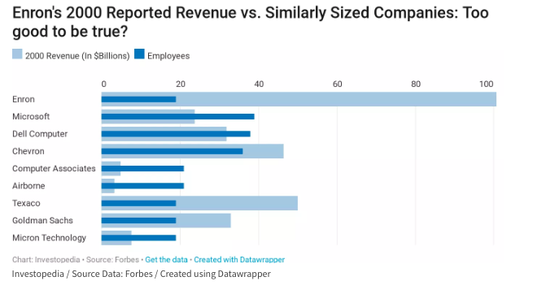
Source: Enron Revenue Comparison, Investopedia, https://www.investopedia.com/updates/enron-scandal-summary/

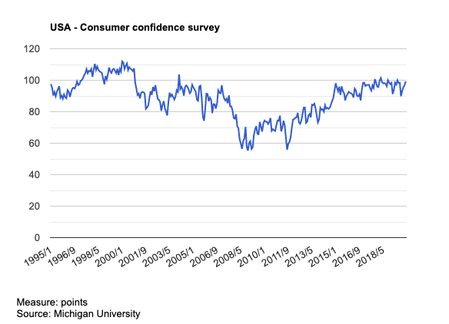
Source: Consumer Confidence, 1995-2018, The Global Economy, https://www.theglobaleconomy.com/USA/consumer_confidence_survey/

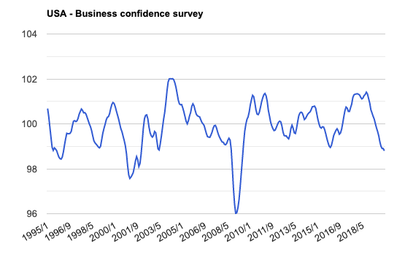
Source: Business Confidence, OECD, The Global Economy, https://www.theglobaleconomy.com/USA/business_confidence_survey/

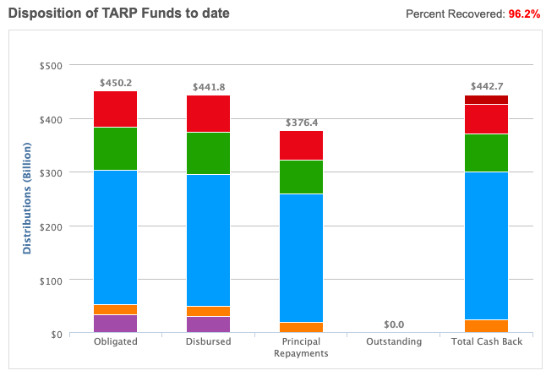
Source: TARP Tracker 2008-2019, U.S. Treasury, https://www.treasury.gov/initiatives/financial-stability/reports/Pages/TARP-Tracker.aspx#All

