Graphs

GRAPH 1: Change in private consumption in Finland and Sweden, 2004-2013 (Statistics Finland, 2014; Statistics Sweden, 2014).

 | 2004 | 2005 | 2006 | 2007 | 2008 | 2009 | 2010 | 2011 | 2012 | 2013
Finland | 3,15001322 | 3,088772 | 3,954655 | 3,138828 | 2,055574 | -3,61931 | 3,390848 | 3,280677 | 0,17463 | -0,87063
Sweden | 2,651113468 | 3,305785 | 3,4 | 3,965184 | 0,093023 | 0,650558 | 3,416436 | 1,785714 | 1,403509 | 1,903114

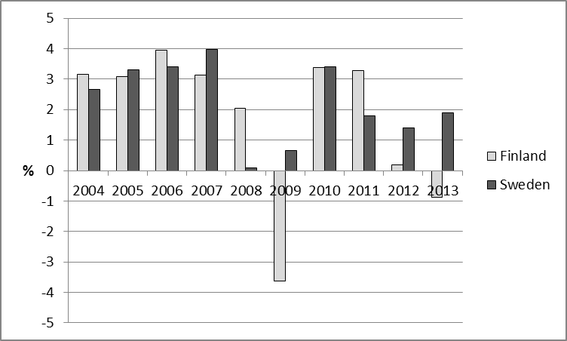

GRAPH 2: Change (2008-2009) in private consumption in Finland and Sweden (Statistics Finland, 2014; Statistics Sweden, 2014).

 |  | Sweden | Finland
 | transportation | -5,03552 | -12,5862
 | restaurants and hotels | -0,38874 | -8,56855
 | communication | 6,910774 | -8,54864
 | furnishings and household equipment | -1,0893 | -7,60169
 | recreation and culture | 0,279823 | -5,90236
 | health | 3,518433 | -5,625
 | alcohol and tobacco | 6,06914 | -2,9791
 | clothing | -1,53082 | -1,18421
 | food | 2,14389 | 0,095928
 | housing | 1,662628 | 3,036815

