**FIGURE 1.** *All levels of Government – Public Investments declared viable*

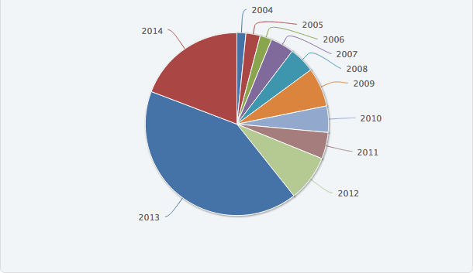

Source: Banco de Proyectos SNIP

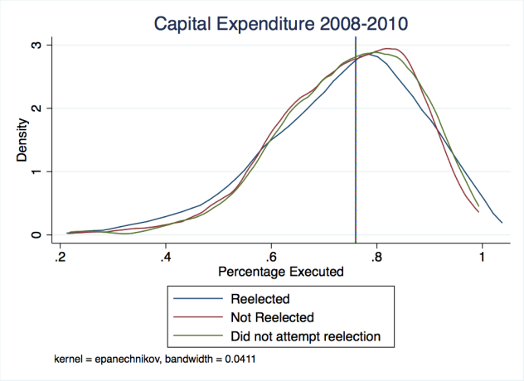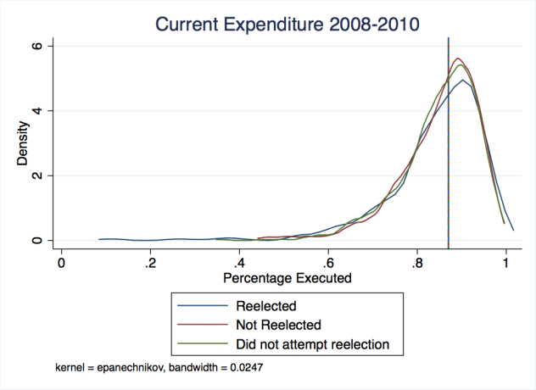**FIGURE 2:** *Aggregate budget expenditure 2008-2010*

Source: Author’s elaboration

**FIGURE 3:** *Budget expenditure in 2008*

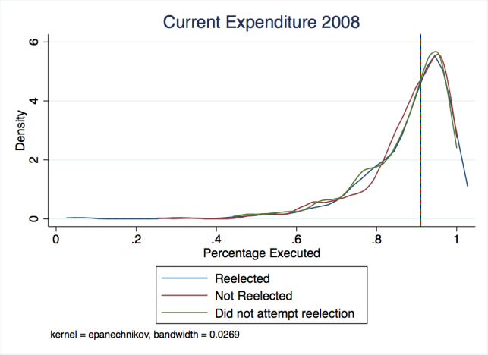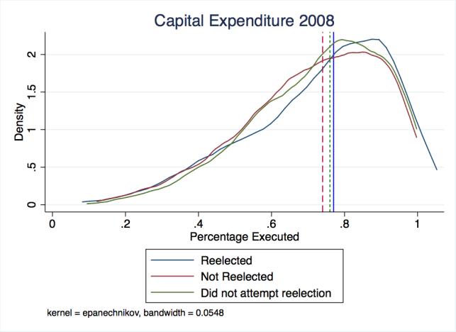

Source: Author’s elaboration

**FIGURE 4:** *Budget expenditure in 2009*

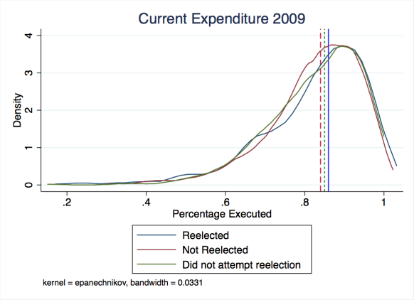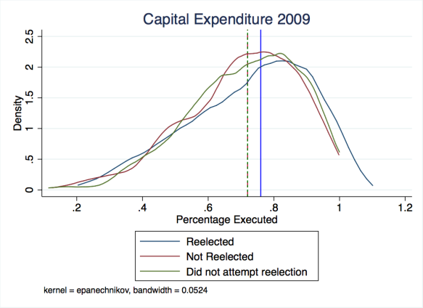

Source: Author’s elaboration

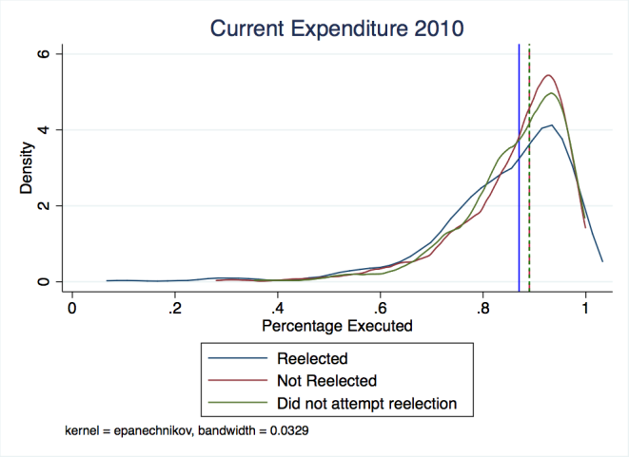**FIGURE 5:** *Budget expenditure in 2010*

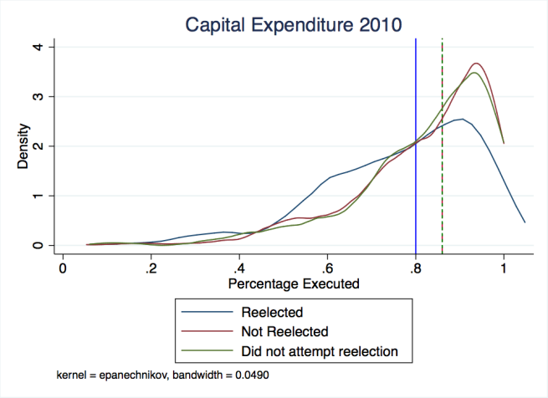

Source: Author’s elaboration

**Appendix**

**TABLE 7:** *Aggregate budget expenditure for 2008-2010*

|  |  |  |  |
| --- | --- | --- | --- |
|  | (1) | (2) | (3) |
| Variables | Marginal Effects | Marginal Effects | Marginal Effects |
|  |  |  |  |
| % Votes obtained in 2006 |  |  | **1.186\*\*\*** |
|  |  |  | (0.151) |
| % Budget Expenditure 2008-10 | 0.0152 | -0.0354 | -0.133 |
|  | (0.128) | (0.131) | (0.127) |
| Is a male candidate |  | **0.200\*\*\*** | **0.204\*\*\*** |
|  |  | (0.0543) | (0.0518) |
| Young (less than 40) |  | 0.123*** | 0.105*** |
|  |  | (0.0390) | (0.0377) |
| District in Poverty Quintile 1 |  | **-0.191\*\*\*** | **-0.155\*\*** |
|  |  | (0.0703) | (0.0716) |
| District in Poverty Quintile 2 |  | **-0.150\*\*** | **-0.111\*** |
|  |  | (0.0640) | (0.0659) |
| District in Poverty Quintile 3 |  | -0.0556 | -0.0274 |
|  |  | (0.0634) | (0.0652) |
| % of Rural Population |  | -0.00589 | 0.0252 |
|  |  | (0.0651) | (0.0632) |
| Ln Pop. 2008 |  | **-0.0264\*** | 0.00131 |
|  |  | (0.0147) | (0.0147) |
| Altitude |  | -2.53e-05* | -1.38e-05 |
|  |  | (1.34e-05) | (1.31e-05) |
| Elected in 2002-2006 |  | -0.0288 | **-0.0965\*\*\*** |
|  |  | (0.0366) | (0.0336) |
| Affiliated to a Regional Movement |  | 0.0534 | 0.0533 |
|  |  | (0.0598) | (0.0583) |
| Affiliated to a Local Organization |  | 0.0267 | 0.00288 |
|  |  | (0.0890) | (0.0849) |
| Affiliated to a National Political Party |  | 0.0465 | 0.0388 |
|  |  | (0.0607) | (0.0593) |
|  |  |  |  |
| Observations | 996 | 995 | 995 |
| Adjusted R-squared | 1.14e-05 | 0.0449 | 0.0885 |
| Standard errors in parentheses |  |  |  |
| *** p<0.01, ** p<0.05, * p<0.1 |  |  |  |

**TABLE 8:** *Aggregate budget expenditure for 2011-2014*

|  |  |  |  |  |
| --- | --- | --- | --- | --- |
|  | (1) | (2) | (3) | (4) |
| Variables | Marginal Effects | Marginal Effects | Marginal Effects | Marginal Effects |
|  |  |  |  |  |
| % Votes obtained in 2010 |  |  | **1.137\*\*\*** | **1.137\*\*\*** |
|  |  |  | (0.143) | (0.143) |
| % Budget Expenditure 2011-14 | 0.151 | 0.0833 | 0.0439 | 0.0439 |
|  | (0.133) | (0.134) | (0.131) | (0.131) |
| Is a male candidate |  | 0.0215 | -0.00200 | -0.00200 |
|  |  | (0.0675) | (0.0676) | (0.0676) |
| Young (less than 40) |  | **0.210\*\*\*** | **0.204\*\*\*** | **0.204\*\*\*** |
|  |  | (0.0421) | (0.0411) | (0.0411) |
| Elected in 2006-2010 |  | **0.0766\*\*** | 0.0231 | 0.0231 |
|  |  | (0.0380) | (0.0362) | (0.0362) |
| % of Rural Population |  | -0.0330 | -0.0281 | -0.0281 |
|  |  | (0.0648) | (0.0632) | (0.0632) |
| Ln Pop. 2011 |  | -0.00627 | 0.0222 | 0.0222 |
|  |  | (0.0137) | (0.0137) | (0.0137) |
| District in Poverty Quintile 1 |  | -0.0397 | 0.0157 | 0.0157 |
|  |  | (0.0775) | (0.0767) | (0.0767) |
| District in Poverty Quintile 2 |  | -0.0192 | 0.0305 | 0.0305 |
|  |  | (0.0696) | (0.0696) | (0.0696) |
| District in Poverty Quintile 3 |  | 0.00341 | 0.0482 | 0.0482 |
|  |  | (0.0698) | (0.0727) | (0.0727) |
| Altitude |  | -2.53e-05* | -1.06e-05 | -1.06e-05 |
|  |  | (1.32e-05) | (1.30e-05) | (1.30e-05) |
|  |  |  |  |  |
| Observations | 1,005 | 1,004 | 1,004 | 1,004 |
| Adjusted R-squared | 0.00107 | 0.0375 | 0.0829 | 0.0829 |
| Standard errors in parentheses |  |  |  |  |
| *** p<0.01, ** p<0.05, * p<0.1 |  |  |  |  |

**TABLE 9:** *Aggregate results per voter for 2011-2014*

|  |  |  |  |  |
| --- | --- | --- | --- | --- |
|  | (1) | (2) | (3) | (4) |
| Variables | Marginal Effects | Marginal Effects | Marginal Effects | Marginal Effects |
|  |  |  |  |  |
| % Eletoral 2010 |  |  | **1.132\*\*\*** | **1.119\*\*\*** |
|  |  |  | (0.145) | (0.146) |
| Cap. Exp. Per voter 2011 | 8.71e-06 | 6.55e-06 | 3.32e-06 | 1.29e-05 |
|  | (1.32e-05) | (1.38e-05) | (1.32e-05) | (1.61e-05) |
| Cap. Exp. Per voter 2012 | -9.65e-06 | -4.94e-06 | -1.00e-05 | -1.51e-05 |
|  | (1.44e-05) | (1.42e-05) | (1.39e-05) | (1.46e-05) |
| Cap. Exp. Per voter 2013 | **2.30e-05\*\*** | **2.19e-05\*** | **2.34e-05\*\*** | **2.83E-05\*\*** |
|  | (1.14e-05) | (1.13e-05) | (1.08e-05) | (1.11e-05) |
| Cap. Exp. Per voter 2014 | -1.06e-05 | -7.24e-06 | -1.07e-05 | -9.73e-06 |
|  | (9.73e-06) | (9.68e-06) | (9.52e-06) | (9.95e-06) |
| Curr. Exp. Per voter 2011 |  |  |  | -3.22e-05 |
|  |  |  |  | (6.88e-05) |
| Curr. Exp. Per voter 2012 |  |  |  | -0.000118 |
|  |  |  |  | (8.02e-05) |
| Curr. Exp. Per voter 2013 |  |  |  | 7.84e-05 |
|  |  |  |  | (7.36e-05) |
| Curr. Exp. Per voter 2014 |  |  |  | 4.11e-05 |
|  |  |  |  | (5.71e-05) |
| Is a male candidate |  | 0.0294 | 0.00150 | 0.00555 |
|  |  | (0.0664) | (0.0667) | (0.0663) |
| Young (less than 40) |  | **0.206\*\*\*** | **0.200\*\*\*** | **0.204\*\*\*** |
|  |  | (0.0420) | (0.0411) | (0.0411) |
| Elected in 2006-2010 |  | 0.0752** | 0.0250 | 0.0199 |
|  |  | (0.0381) | (0.0363) | (0.0363) |
| % of Rural Population |  | -0.0372 | -0.0284 | -0.0269 |
|  |  | (0.0649) | (0.0634) | (0.0632) |
| Ln Poblc. 2011 |  | -0.00163 | 0.0234* | 0.0231 |
|  |  | (0.0141) | (0.0140) | (0.0144) |
| District in Poverty Quintile 1 |  | -0.0413 | 0.0114 | -0.00736 |
|  |  | (0.0772) | (0.0765) | (0.0769) |
| District in Poverty Quintile 2 |  | -0.0168 | 0.0295 | 0.0129 |
|  |  | (0.0695) | (0.0694) | (0.0697) |
| District in Poverty Quintile 3 |  | 0.00126 | 0.0441 | 0.0298 |
|  |  | (0.0695) | (0.0722) | (0.0710) |
| Altitude |  | **-2.75e-05\*\*** | **-1.11e-05** | -1.12e-05 |
|  |  | (1.29e-05) | (1.27e-05) | (1.28e-05) |
|  |  |  |  |  |
| Observations | 1005 | 1004 | 1004 | 1004 |
| Adjusted R-squared | 0.00654 | 0.0423 | 0.0869 | 0.0907 |
| Standard errors in parentheses |  |  |  |  |
| *** p<0.01, ** p<0.05, * p<0.1 |  |  |  |  |

**TABLE 10:** *Identification equation for candidates who decided to run for reelection in 2014*

|  |  |  |  |  |
| --- | --- | --- | --- | --- |
|  | (1) | (2) | (3) | (4) |
| Variables | Marginal Effects | Marginal Effects | Marginal Effects | Marginal Effects |
|  |  |  |  |  |
| % Votes obtained in 2010 |  |  |  | -0.161 |
|  |  |  |  | (0.133) |
| % Curr. E. 2011 |  |  |  | 0.0264 |
|  |  |  |  | (0.109) |
| % Curr. E. 2012 |  |  |  | 0.0282 |
|  |  |  |  | (0.111) |
| % Curr. E. 2013 |  |  |  | 0.0193 |
|  |  |  |  | (0.119) |
| % Capital E. 2011 |  | **-0.154\*\*** | **-0.149\*\*** | **-0.154\*\*** |
|  |  | (0.0641) | (0.0656) | (0.0671) |
| % Capital E. 2012 |  | 0.0499 | 0.0282 | 0.0271 |
|  |  | (0.0650) | (0.0633) | (0.0640) |
| % Capital E. 2013 |  | **0.214\*\*\*** | **0.173\*\*** | **0.170\*\*** |
|  |  | (0.0701) | (0.0679) | (0.0683) |
| Is a male candidate | -0.0902 |  | -0.0917 | -0.0898 |
|  | (0.0611) |  | (0.0608) | (0.0611) |
| Young (less than 40) | -0.0117 |  | -0.0109 | -0.0113 |
|  | (0.0308) |  | (0.0308) | (0.0308) |
| Elected in 2006-2010 | -0.0360 |  | -0.0344 | -0.0287 |
|  | (0.0305) |  | (0.0304) | (0.0308) |
| % of Rural Population | -0.00868 |  | -0.0122 | -0.0158 |
|  | (0.0518) |  | (0.0518) | (0.0520) |
| Ln Pop. 2011 | 0.00456 |  | -0.000869 | -0.00513 |
|  | (0.0115) |  | (0.0118) | (0.0123) |
| District in Poverty Quintile 1 | 0.00190 |  | 0.00348 | -0.00276 |
|  | (0.0753) |  | (0.0754) | (0.0759) |
| District in Poverty Quintile 2 | 0.0420 |  | 0.0449 | 0.0393 |
|  | (0.0705) |  | (0.0705) | (0.0710) |
| District in Poverty Quintile 3 | -0.0471 |  | -0.0467 | -0.0501 |
|  | (0.0727) |  | (0.0726) | (0.0731) |
| Altitude | **-0.000103\*\*\*** |  | **-0.000103\*\*\*** | **-0.000104\*\*\*** |
|  | (1.00e-05) |  | (1.01e-05) | (1.02e-05) |
|  |  |  |  |  |
| Observations | 1,604 | 1,605 | 1,604 | 1,604 |
| Adjusted R-squared | 0.0624 | 0.00626 | 0.0671 | 0.0680 |

**TABLE 11:** *Identification equation for candidates who decided to run for reelection in 2010*

|  |  |  |  |  |
| --- | --- | --- | --- | --- |
|  | (1) | (2) | (3) | (4) |
| Variables | Marginal Effects | Marginal Effects | Marginal Effects | Marginal Effects |
|  |  |  |  |  |
| % Votes obtained in 2010 |  |  |  | 0.119 |
|  |  |  |  | (0.139) |
| % Curr. E. 2008 |  | -0.0534 | -0.00312 | -0.00792 |
|  |  | (0.0724) | (0.0740) | (0.0742) |
| % Curr. E. 2009 |  | 0.0286 | 7.25e-05 | -0.00183 |
|  |  | (0.0770) | (0.0783) | (0.0783) |
| % Curr. E. 2008 |  |  | 0.122 | 0.122 |
|  |  |  | (0.125) | (0.125) |
| % Curr. E. 2009 |  |  | -0.0577 | -0.0574 |
|  |  |  | (0.113) | (0.113) |
| Is a male candidate | **-0.128\*** |  | **-0.127\*** | **-0.128\*** |
|  | (0.0683) |  | (0.0686) | (0.0685) |
| Young (less than 40) | -0.0174 |  | -0.0185 | -0.0194 |
|  | (0.0294) |  | (0.0295) | (0.0295) |
| District in Poverty Quintile 1 | **-0.189\*\*** |  | **-0.197\*\*\*** | **-0.192\*\*** |
|  | (0.0739) |  | (0.0742) | (0.0747) |
| District in Poverty Quintile 2 | -0.0929 |  | -0.0981 | -0.0932 |
|  | (0.0709) |  | (0.0712) | (0.0716) |
| District in Poverty Quintile 3 | -0.0592 |  | -0.0619 | -0.0585 |
|  | (0.0755) |  | (0.0758) | (0.0758) |
| % of Rural Population | 0.0207 |  | 0.0201 | 0.0222 |
|  | (0.0521) |  | (0.0523) | (0.0523) |
| Ln Pop. 2008 | 0.0206* |  | 0.0192 | 0.0220* |
|  | (0.0123) |  | (0.0126) | (0.0130) |
| Altitude | **-4.74e-05\*\*\*** |  | **-4.64e-05\*\*\*** | **-4.50e-05\*\*\*** |
|  | (1.04e-05) |  | (1.06e-05) | (1.07e-05) |
| Elected in 2002-06 | **-0.145\*\*\*** |  | **-0.145\*\*\*** | **-0.150\*\*\*** |
|  | (0.0295) |  | (0.0295) | (0.0301) |
|  |  |  |  |  |
| Observations | 1,614 | 1,615 | 1,614 | 1,614 |
| Adjusted R-squared | 0.0537 | 0.000256 | 0.0542 | 0.0545 |
| Standard errors in parentheses |  |  |  |  |
| *** p<0.01, ** p<0.05, * p<0.1 |  |  |  |  |

**TABLE 12:** *Disaggregated Capital Expenditure for 2008-2010*

|  |  |  |  |  |
| --- | --- | --- | --- | --- |
|  | (1) | (2) | (3) | (4) |
| Variables | Marginal Effects | Marginal Effects | Marginal Effects | Marginal Effects |
|  |  |  |  |  |
| % Votes obtained in 2006 |  |  | **1.104\*\*\*** | **1.093\*\*\*** |
|  |  |  | (0.151) | (0.150) |
| % Capital E. Others 2008 = o, | - | - | - | - |
|  |  |  |  |  |
| % Capital E. Others 2009 | -0.0460 | -0.0647 | -0.0421 | -0.0528 |
|  | (0.0406) | (0.0408) | (0.0398) | (0.0397) |
| % Capital E. Others 2010 | 0.00670 | 0.00524 | -0.00419 | 0.00182 |
|  | (0.0384) | (0.0383) | (0.0373) | (0.0370) |
| % Capital E. Security 2008 | 0.0736 | **0.104\*** | **0.103\*** | **0.106\*** |
|  | (0.0617) | (0.0618) | (0.0606) | (0.0605) |
| % Capital E. Security 2009 | **0.138\*\*** | **0.159\*\*\*** | **0.145\*\*\*** | **0.147\*\*\*** |
|  | (0.0550) | (0.0546) | (0.0530) | (0.0526) |
| % Capital E. Security 2010 | **-0.143\*\*** | **-0.156\*\*\*** | **-0.175\*\*\*** | **-0.164\*\*\*** |
|  | (0.0561) | (0.0547) | (0.0535) | (0.0537) |
| % Capital E. Infrastruc. 2008 | **0.0768\*** | **0.0959\*\*** | 0.0494 | 0.0507 |
|  | (0.0430) | (0.0449) | (0.0445) | (0.0415) |
| % Capital E. Infrastruc. 2009 | **0.118**\* | 0.0953 | 0.0711 | 0.0469 |
|  | (0.0660) | (0.0639) | (0.0625) | (0.0634) |
| % Capital E. Infrastruc. 2010 | **-0.257\*\*\*** | **-0.299\*\*\*** | **-0.285\*\*\*** | **-0.282\*\*\*** |
|  | (0.0721) | (0.0722) | (0.0700) | (0.0709) |
| % Capital E. Product. 2008 | -0.0483 | -0.0367 | -0.0495 | -0.0549 |
|  | (0.0701) | (0.0696) | (0.0674) | (0.0671) |
| % Capital E. Product. 2009 | -0.0270 | 0.00126 | 0.00601 | 0.0183 |
|  | (0.0415) | (0.0414) | (0.0405) | (0.0403) |
| % Capital E. Product. 2010 | -0.0438 | 0.00924 | 0.00314 | 0.0151 |
|  | (0.0384) | (0.0389) | (0.0381) | (0.0378) |
| % Capital E. B. Needs 2008 | 0.0839 | 0.0951 | 0.0896 | 0.105* |
|  | (0.0586) | (0.0587) | (0.0566) | (0.0570) |
| % Capital E. B. Needs 2009 | 0.0773 | 0.0791 | 0.0697 | 0.0734 |
|  | (0.0575) | (0.0584) | (0.0571) | (0.0568) |
| % Capital E. B. Needs 2010 | **-0.116\*\*** | **-0.0937\*** | **-0.0784** | **-0.0985\*** |
|  | (0.0544) | (0.0547) | (0.0536) | (0.0538) |
| % Curr. E. Others 2008 |  |  |  | - |
|  |  |  |  |  |
| % Curr. E. Others 2009 |  |  |  | -0.0550 |
|  |  |  |  | (0.0716) |
| % Curr. E. Others 2010 |  |  |  | 0.0183 |
|  |  |  |  | (0.0639) |
| % Curr. E. Security 2008 |  |  |  | 0.175 |
|  |  |  |  | (0.157) |
| % Curr. E. Security 2009 |  |  |  | -0.0590 |
|  |  |  |  | (0.141) |
| % Curr. E. Security 2010 |  |  |  | -0.0785 |
|  |  |  |  | (0.134) |
| % Curr. E. Infrastruc. 2008 |  |  |  | -0.0312 |
|  |  |  |  | (0.0342) |
| % Curr. E. Infrastruc. 2009 |  |  |  | 0.0665 |
|  |  |  |  | (0.0618) |
| % Curr. E. Infrastruc. 2010 |  |  |  | -0.0562 |
|  |  |  |  | (0.0546) |
| % Curr. E. Product. 2008 |  |  |  | -0.0536 |
|  |  |  |  | (0.0385) |
| % Curr. E. Product. 2009 |  |  |  | **0.168\*\*** |
|  |  |  |  | (0.0695) |
| % Curr. E. Product. 2010 |  |  |  | **-0.159\*\*** |
|  |  |  |  | (0.0658) |
| % Curr. E. B. Needs 2008 |  |  |  | - |
|  |  |  |  |  |
| % Curr. E. B. Needs 2009 |  |  |  | -0.0140 |
|  |  |  |  | (0.0461) |
| % Curr. E. B. Needs 2010 |  |  |  | **-0.0816\*\*** |
|  |  |  |  | (0.0407) |
| Is a male candidate |  | **0.192\*\*\*** | **0.195\*\*\*** | **0.189\*\*\*** |
|  |  | (0.0558) | (0.0532) | (0.0552) |
| Young (less than 40) |  | **0.130\*\*\*** | **0.111\*\*\*** | **0.109\*\*\*** |
|  |  | (0.0383) | (0.0371) | (0.0368) |
| District in Poverty Quintile 1 |  | **-0.222\*\*\*** | **-0.186\*\*\*** | **-0.192\*\*\*** |
|  |  | (0.0682) | (0.0704) | (0.0699) |
| District in Poverty Quintile 2 |  | **-0.159\*\*** | **-0.119\*** | **-0.123\*** |
|  |  | (0.0635) | (0.0661) | (0.0656) |
| District in Poverty Quintile 3 |  | -0.0696 | -0.0391 | -0.0518 |
|  |  | (0.0609) | (0.0633) | (0.0623) |
| % of Rural Population |  | -0.00269 | 0.0319 | 0.0301 |
|  |  | (0.0638) | (0.0623) | (0.0627) |
| Ln Pop. 2008 |  | -0.0167 | 0.00780 | 0.0313* |
|  |  | (0.0149) | (0.0149) | (0.0166) |
| Altitude |  | **-2.60e-05\*\*** | -1.50e-05 | -1.24e-05 |
|  |  | (1.29e-05) | (1.27e-05) | (1.30e-05) |
| Elected 2002-2006 |  | **-0.0279** | **-0.0894\*\*\*** | **-0.0965\*\*\*** |
|  |  | (0.0361) | (0.0337) | (0.0328) |
| Affiliated to a Regional Movement |  | 0.0139 | 0.0142 | 0.0337 |
|  |  | (0.0586) | (0.0572) | (0.0569) |
| Affiliated to a Local Organization |  | 0.0143 | -0.00517 | 0.0263 |
|  |  | (0.0850) | (0.0814) | (0.0846) |
| Affiliated to a National Political Party |  | 0.0228 | 0.0114 | 0.0303 |
|  |  | (0.0591) | (0.0576) | (0.0577) |
|  |  |  |  |  |
| Observations | 996 | 995 | 995 | 995 |
| Adjusted R-squared | 0.0412 | 0.0915 | 0.130 | 0.150 |
| Standard errors in parentheses |  |  |  |  |
| *** p<0.01, ** p<0.05, * p<0.1 |  |  |  |  |

**TABLE 13:** *Disaggregated Capital Expenditure 2011-2014*

|  |  |  |  |  |
| --- | --- | --- | --- | --- |
|  | (1) | (2) | (3) | (4) |
| Variables | Marginal Effects | Marginal Effects | Marginal Effects | Marginal Effects |
|  |  |  |  |  |
| % Votes obtained in 2010 |  |  | **1.080\*\*\*** | **1.057\*\*\*** |
|  |  |  | (0.144) | (0.144) |
| % Capital E. Others 2011 = o, | - | - | - | - |
|  |  |  |  |  |
| % Capital E. Others 2012 | -0.574 | -0.601 | -0.433 | -0.522 |
|  | (0.981) | (0.918) | (0.876) | (0.892) |
| % Capital E. Others 2013 | -0.157 | -0.136 | -0.0945 | -0.115 |
|  | (0.136) | (0.132) | (0.125) | (0.125) |
| % Capital E. Others 2014 | 0.00879 | 0.0303 | 0.0253 | 0.0242 |
|  | (0.0785) | (0.0780) | (0.0758) | (0.0755) |
| % Capital E. Security 2011 | -0.0514 | -0.0427 | -0.0209 | -0.0310 |
|  | (0.0551) | (0.0547) | (0.0532) | (0.0532) |
| % Capital E. Security 2012 | 0.0362 | 0.0338 | 0.0162 | 0.0191 |
|  | (0.0563) | (0.0565) | (0.0549) | (0.0546) |
| % Capital E. Security 2013 | 0.0620 | 0.0899 | 0.0867 | 0.1000 |
|  | (0.0634) | (0.0628) | (0.0607) | (0.0609) |
| % Capital E. Security 2014 | **-0.144\*\*** | **-0.133\*\*** | **-0.117\*\*** | **-0.106\*** |
|  | (0.0564) | (0.0556) | (0.0544) | (0.0550) |
| % Capital E. Infrastruc. 2011 | **0.121\*\*** | 0.0968 | 0.0682 | 0.0605 |
|  | (0.0610) | (0.0619) | (0.0606) | (0.0611) |
| % Capital E. Infrastruc. 2012 | 0.0665 | 0.0469 | 0.0181 | 0.0331 |
|  | (0.0642) | (0.0634) | (0.0619) | (0.0620) |
| % Capital E. Infrastruc. 2013 | 0.0886 | 0.0560 | 0.0486 | 0.0454 |
|  | (0.0640) | (0.0633) | (0.0624) | (0.0625) |
| % Capital E. Infrastruc. 2014 | -0.0176 | -0.0226 | -0.0286 | -0.0354 |
|  | (0.0572) | (0.0561) | (0.0544) | (0.0545) |
| % Capital E. Product. 2011 | -0.0476 | -0.0203 | -0.0241 | -0.0271 |
|  | (0.0373) | (0.0372) | (0.0361) | (0.0359) |
| % Capital E. Product. 2012 | -0.0445 | -0.0387 | -0.0398 | -0.0371 |
|  | (0.0397) | (0.0395) | (0.0384) | (0.0386) |
| % Capital E. Product. 2013 | 0.00909 | 0.0244 | 0.0253 | 0.0203 |
|  | (0.0408) | (0.0402) | (0.0391) | (0.0391) |
| % Capital E. Product. 2014 | 0.0210 | 0.0478 | 0.0414 | 0.0341 |
|  | (0.0357) | (0.0357) | (0.0348) | (0.0348) |
| % Capital E. B. Needs 2011 | -0.0417 | -0.0538 | -0.0702 | -0.0656 |
|  | (0.0481) | (0.0477) | (0.0465) | (0.0469) |
| % Capital E. B. Needs 2012 | -0.0439 | -0.0548 | -0.0285 | -0.0200 |
|  | (0.0493) | (0.0489) | (0.0477) | (0.0477) |
| % Capital E. B. Needs 2013 | **0.116\*\*** | **0.121\*\*** | **0.113\*\*** | **0.116\*\*** |
|  | (0.0494) | (0.0492) | (0.0480) | (0.0477) |
| % Capital E. B. Needs 2014 | 0.0499 | 0.0547 | 0.0531 | 0.0547 |
|  | (0.0484) | (0.0482) | (0.0473) | (0.0472) |
| % Curr. E. Others 2011 |  |  |  | 0.0224 |
|  |  |  |  | (0.0579) |
| % Curr. E. Others 2012 |  |  |  | 0.00461 |
|  |  |  |  | (0.0623) |
| % Curr. E. Others 2013 |  |  |  | **-0.193\*\*\*** |
|  |  |  |  | (0.0683) |
| % Curr. E. Others 2014 |  |  |  | **0.127\*\*** |
|  |  |  |  | (0.0617) |
| % Curr. E. Security 2011 |  |  |  | 0.0895 |
|  |  |  |  | (0.135) |
| % Curr. E. Security 2012 |  |  |  | **-0.249\*** |
|  |  |  |  | (0.140) |
| % Curr. E. Security 2013 |  |  |  | 0.176 |
|  |  |  |  | (0.162) |
| % Curr. E. Security 2014 |  |  |  | -0.163 |
|  |  |  |  | (0.164) |
| % Curr. E. Infrastruc. 2011 |  |  |  | 0.00718 |
|  |  |  |  | (0.0446) |
| % Curr. E. Infrastruc. 2012 |  |  |  | **0.0678\*** |
|  |  |  |  | (0.0409) |
| % Curr. E. Infrastruc. 2013 |  |  |  | **0.115\*\*\*** |
|  |  |  |  | (0.0433) |
| % Curr. E. Infrastruc. 2014 |  |  |  | -0.0164 |
|  |  |  |  | (0.0414) |
| % Curr. E. Product. 2011 |  |  |  | -0.0208 |
|  |  |  |  | (0.0558) |
| % Curr. E. Product. 2012 |  |  |  | -0.0419 |
|  |  |  |  | (0.0514) |
| % Curr. E. Product. 2013 |  |  |  | 0.0375 |
|  |  |  |  | (0.0499) |
| % Curr. E. Product. 2014 |  |  |  | 0.0612 |
|  |  |  |  | (0.0504) |
| % Curr. E. B. Needs 2011 |  |  |  | 0.0254 |
|  |  |  |  | (0.0341) |
| % Curr. E. B. Needs 2012 |  |  |  | -0.0109 |
|  |  |  |  | (0.0390) |
| % Curr. E. B. Needs 2013 |  |  |  | 0.0352 |
|  |  |  |  | (0.0430) |
| % Curr. E. B. Needs 2014 |  |  |  | -0.0466 |
|  |  |  |  | (0.0416) |
| Is a male candidate |  | 0.0126 | -0.00699 | -0.0148 |
|  |  | (0.0681) | (0.0676) | (0.0673) |
| Young (less than 40) |  | **0.206\*\*\*** | **0.201\*\*\*** | **0.210\*\*\*** |
|  |  | (0.0420) | (0.0413) | (0.0413) |
| Elected 2006-2010 |  | **0.0837\*\*** | 0.0312 | 0.0471 |
|  |  | (0.0381) | (0.0365) | (0.0370) |
| % of Rural Population |  | -0.0432 | -0.0358 | -0.0248 |
|  |  | (0.0651) | (0.0635) | (0.0639) |
| Ln Pop. 2011 |  | -0.00919 | 0.0167 | -0.00106 |
|  |  | (0.0141) | (0.0142) | (0.0160) |
| District in Poverty Quintile 1 |  | -0.0507 | 0.00304 | -0.0172 |
|  |  | (0.0793) | (0.0791) | (0.0790) |
| District in Poverty Quintile 2 |  | -0.0365 | 0.0138 | 0.0104 |
|  |  | (0.0711) | (0.0718) | (0.0716) |
| District in Poverty Quintile 3 |  | -0.0124 | 0.0324 | 0.0390 |
|  |  | (0.0694) | (0.0731) | (0.0735) |
| Altitude |  | **-2.74e-05\*\*** | -1.28e-05 | -1.25e-05 |
|  |  | (1.33e-05) | (1.32e-05) | (1.34e-05) |
|  |  |  |  |  |
| Observations | 1,004 | 1,003 | 1,003 | 1,003 |
| Adjusted R-squared | 0.0245 | 0.0609 | 0.102 | 0.129 |
| Standard errors in parentheses |  |  |  |  |
| *** p<0.01, ** p<0.05, * p<0.1 |  |  |  |  |

**FIGURE 11.** *Distribution of votes obtained in the electoral process of 2006*





Source: Author’s elaboration

**FIGURE 12.** *Distribution of votes obtained in the electoral process of 2010*



Source: Author’s elaboration

**FIGURE 13.** *Distribution of aggregate expenditures for the years 2008-2010*





Source: Author’s elaboration

**FIGURE 14.** *Distribution of budget expenditures in 2008*





Source: Author’s elaboration

**FIGURE 15.** *Distribution of budget expenditures in 2009*





Source: Author’s elaboration

**FIGURE 16.** *Distribution of budget expenditures in 2010*





Source: Author’s elaboration

**FIGURE 17.** *Distribution of aggregate expenditures for the years 2011-2014*



Source: Author’s elaboration

**FIGURE 18.** *Distribution of budget expenditures in 2011*

Source: Author’s elaboration

**FIGURE 19.** *Distribution of budget expenditures in 2012*







Source: Author’s elaboration

**FIGURE 20.** *Distribution of budget expenditures in 2013*



Source: Author’s elaboration

**FIGURE 21.** *Distribution of budget expenditures in 2014*





Source: Author’s elaboration