Journal of
Economics and Political Economy

www.kspjournals.org

Conflict/Relation Interests Form [#07]

Number of the article

Title of the article

Analysis of Asymmetries in the Tax-Spending Nexus in Burundi

Address PO BOX 1280, Bujumbura, Burundi

Email arcade_ndoricimpa@yahoo.com

Tel. +257 75281293

Country BURUNDI

Dear Editor,

Data which were used in the article that has been given information about, were provided from most reliable sources. Findings, results and suggestions have been presented objectively. Findings, results and suggestions do not have any intentions for damaging and/or supporting any institution or organization.

Beside that findings results and suggestions do not include any situation about conflict of interest and/or conflict-relation interests with the institution which I work for.

On the other hand findings, results and suggestions do not include any situation about conflict of interest or conflict-relation interests with any institutional identity of JEPE, publishing policy of JEPE, editor and/or anyone in the board of editor.

In conclusion findings, results and suggestions of the article have been presented according to principle of objectivity. They do not include any case regarding with conflict of interest or conflict-relation interests with any institution and/or organization, institution and/or organization which I work for and institutional identity of JEPE.

I declare and undertake suitability of the article to all these points.

Sincerely,

Author’s (or Corresponding Author):

Full Name: Arcade Ndoricimpa

Signature: 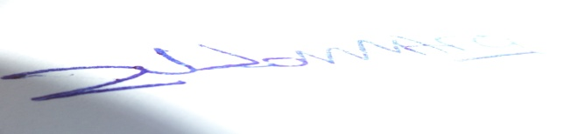
Date: January 23, 2017

