**Figure 2: Expected Workers’ Compensation Benefits**

**(as a Percentage of the Annual Average Earnings in Manufacturing)**

**1930**

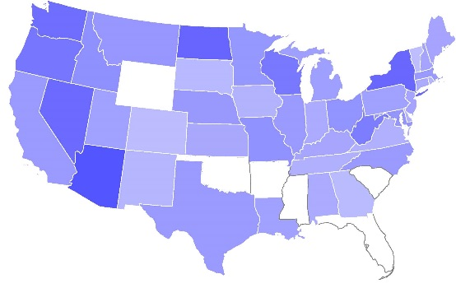

**1940**

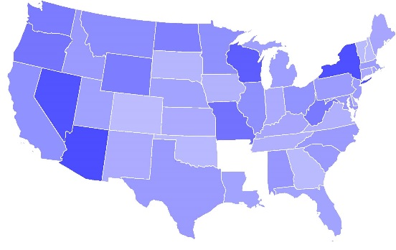

**1950**

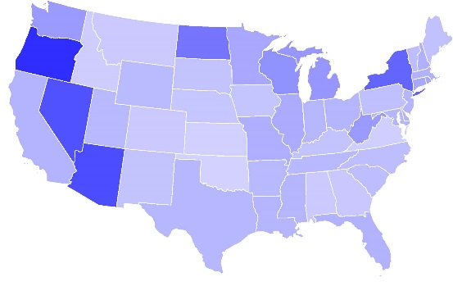

**1960**

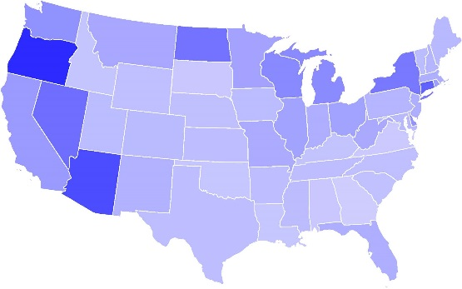

No WC Law

**1970**

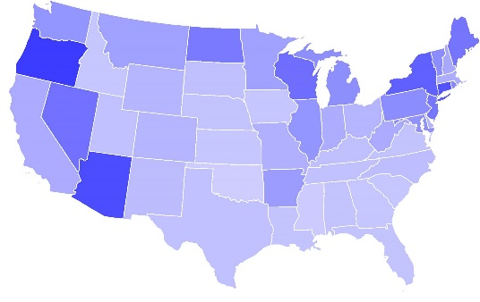

**1980**

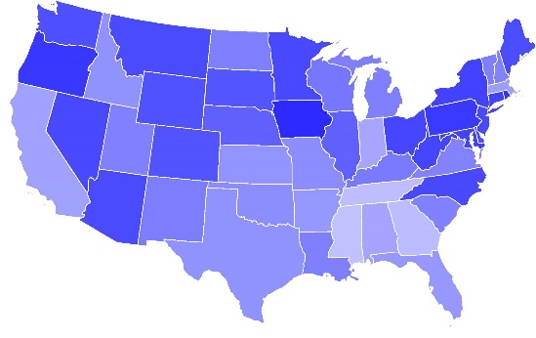

**1990**

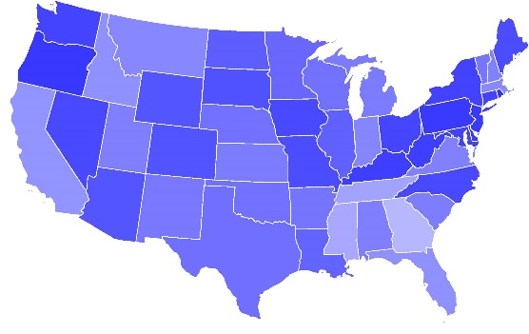

**2000**

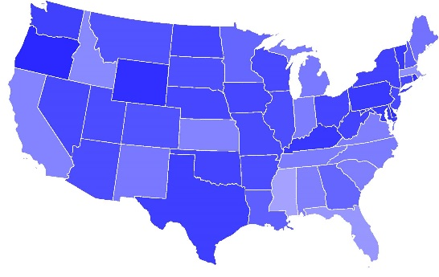

Percentage of manufacturing wage replaced:



5% 50% 95%