Current Trends in the Economic Development of the Participating in the Tripartite Free Trade Area Regional Economic Communities

Table 1. COMESA – general economic indicators (2013)
 | Area (mln. sq. кm) | Population (mln.) | GDP (mln. USD) | GDP (USD p.c.) | GNI (mln. USD) | Imports (mln. USD) | Exports (mln. USD) | Trade (mln. USD) | Trade balance (mln. USD)
Burundi | 28 | 9,8 | 2472 | 271 | 2463 | 780 | 130 | 910 | -650
Comoros | 2 | 0,7 | 596 | 810 | 595 | 300 | 25 | 325 | -275
Congo, DR | 2345 | 65,7 | 17204 | 231 | 16062 | 6100 | 6300 | 12400 | 200
Djibouti | 23 | 0,9 | 1049 | 1203 | 1120 | 580 | 95 | 675 | -485
Egypt | 1001 | 80,7 | 262832 | 2781 | 256347 | 69813 | 29397 | 99210 | -40416
Eritrea | 118 | 6,1 | 3092 | 482 | 3064 | 950 | 470 | 1420 | -480
Ethiopia | 1104 | 91,7 | 41605 | 357 | 41511 | 12000 | 3000 | 15000 | -9000
Kenya | 580 | 43,2 | 40697 | 808 | 40527 | 16290 | 6127 | 22417 | -10163
Libya | 1760 | 6,2 | 62360 | 9957 | 61985 | 23000 | 59000 | 82000 | 36000
Madagascar | 587 | 22,3 | 9975 | 465 | 9686 | 3050 | 1500 | 4550 | -1550
Malawi | 118 | 15,9 | 4264 | 365 | 4139 | 2350 | 1300 | 3650 | -1050
Mauritius | 2 | 1,3 | 10486 | 8755 | 10598 | 5200 | 2650 | 7850 | -2550
Rwanda | 26 | 11,5 | 7103 | 583 | 7029 | 2000 | 470 | 2470 | -1530
Seychelles | 0 | 0,1 | 1129 | 12321 | 1087 | 800 | 497 | 1297 | -303
Sudan | 2506 | 37,2 | 58769 | 1866 | 56347 | 9100 | 3100 | 12200 | -6000
Swaziland | 17 | 1,2 | 3744 | 3831 | 3454 | 1950 | 1900 | 3850 | -50
Uganda | 242 | 36,3 | 19881 | 487 | 16760 | 5920 | 2404 | 8324 | -3516
Zambia | 753 | 14,1 | 20678 | 1425 | 19542 | 8000 | 8550 | 16550 | 550
Zimbabwe | 391 | 13,7 | 9802 | 757 | 9420 | 4400 | 3800 | 8200 | -600
Source: African Development Indicators, World Bank and own calculations.

Table 2. COMESA intracommunity trade (Million USD)
 | Exports |  |  |  | Imports |  |  |  | Total trade
 | 2003 | 2012 | Share | Growth¹ | 2003 | 2012 | Share | Growth ¹ | 2012 | Share ²
Total | 2203 | 10890 | 6,9³ | 19,4 | 2004 | 9403 | 7,1³ | 18,7 | 20292 | 7,0³
Burundi | 42 | 139 | 1,3 | 14,1 | 3 | 31 | 0,3 | 28,6 | 170 | 25,9
Comoros | 13 | 27 | 0,2 | 8,8 | 1 | 1 | 0,0 | 2,8 | 28 | 9,3
Congo, DR | 145 | 1661 | 15,3 | 31,1 | 25 | 1285 | 13,7 | 54,7 | 2946 | 24,5
Djibouti | 141 | 123 | 1,1 | -1,5 | 64 | 13 | 0,1 | -16,1 | 136 | 3,3
Egypt | 225 | 835 | 7,7 | 15,7 | 237 | 2480 | 26,4 | 29,8 | 3315 | 3,2
Ethiopia | 116 | 325 | 3,0 | 12,1 | 130 | 100 | 1,1 | -2,9 | 425 | 4,3
Kenya | 155 | 714 | 6,6 | 18,5 | 810 | 1823 | 19,4 | 9,4 | 2537 | 10,8
Libya | 126 | 1576 | 14,5 | 32,4 | 35 | 153 | 1,6 | 18,0 | 1729 | 2,3
Madagascar | 69 | 202 | 1,9 | 12,7 | 52 | 38 | 0,4 | -3,3 | 240 | 5,6
Malawi | 74 | 299 | 2,7 | 16,8 | 59 | 190 | 2,0 | 13,8 | 490 | 17,8
Mauritius | 93 | 155 | 1,4 | 5,9 | 149 | 216 | 2,3 | 4,2 | 371 | 5,1
Rwanda | 123 | 476 | 4,4 | 16,2 | 3 | 121 | 1,3 | 52,0 | 598 | 38,4
Seychelles | 14 | 43 | 0,4 | 13,4 | 0 | 39 | 0,4 | 68,8 | 82 | 5,8
Sudan | 202 | 782 | 7,2 | 16,2 | 96 | 381 | 4,0 | 16,5 | 1163 | 8,1
Uganda | 379 | 973 | 8,9 | 11,1 | 142 | 587 | 6,2 | 17,1 | 1560 | 26,5
Zambia | 257 | 1873 | 17,2 | 24,7 | 88 | 1503 | 16,0 | 37,0 | 3376 | 24,7
Zimbabwe | 29 | 687 | 6,3 | 42,1 | 109 | 441 | 4,7 | 16,8 | 1127 | 16,7
Notes: ¹Average annual growth 2003-2012, %; ² of country’s total trade; ³ of REC.
No data for Eritrea and Swaziland (share of total REC trade resp. 0.5 and 1.3%).
Source: IMF DOTS and own calculations.

Table 3. ЕАС – general economic indicators (2013)
 | Area (mln. sq. кm) | Population (mln.) | GDP (mln. USD) | GDP (USD p.c.) | GNI (mln. USD) | Imports (mln. USD) | Exports (mln. USD) | Trade (mln. USD) | Trade balance (mln. USD)
Burundi | 28 | 9,8 | 2472 | 271 | 2463 | 780 | 130 | 910 | -650
Kenya | 580 | 43,2 | 40697 | 808 | 40527 | 16290 | 6127 | 22417 | -10163
Rwanda | 26 | 11,5 | 7103 | 583 | 7029 | 2000 | 470 | 2470 | -1530
Tanzania | 947 | 47,8 | 28242 | 517 | 27983 | 11114 | 5500 | 16614 | -5614
Uganda | 242 | 36,3 | 19881 | 487 | 16760 | 5920 | 2404 | 8324 | -3516
Source: African Development Indicators, World Bank and own calculations.

Table 4. EAC intracommunity trade (Million USD)
 | Exports |  |  |  | Imports |  |  |  | Total trade
 | 2003 | 2012 | Share | Growth¹ | 2003 | 2012 | Share | Growth ¹ | 2012 | Share ²
Total | 787 | 2582 | 8,0³ | 14,1 | 879 | 2355 | 19,8³ | 11,6 | 4937 | 11,1³
Burundi | 51 | 147 | 5,7 | 12,5 | 3 | 16 | 0,7 | 20,7 | 163 | 25,0
Kenya | 32 | 359 | 13,9 | 30,9 | 711 | 1567 | 66,5 | 9,2 | 1926 | 8,2
Rwanda | 118 | 495 | 19,2 | 17,3 | 1 | 29 | 1,2 | 41,6 | 524 | 33,6
Tanzania | 218 | 636 | 24,6 | 12,6 | 48 | 325 | 13,8 | 23,7 | 961 | 7,5
Uganda | 369 | 944 | 36,6 | 11,0 | 115 | 418 | 17,7 | 15,4 | 1362 | 23,1
Notes: ¹Average annual growth 2003-2012, %; ² of country’s total trade; ³ of REC.
Source: IMF DOTS and own calculations.

Table 5. SADC – general economic indicators (2013)
 | Area (mln. sq. кm) | Population (mln.) | GDP (mln. USD) | GDP (USD p.c.) | GNI (mln. USD) | Imports (mln. USD) | Exports (mln. USD) | Trade (mln. USD) | Trade balance (mln. USD)
Angola | 1247 | 20,8 | 114147 | 5318 | 102613 | 24000 | 73000 | 97000 | 49000
Botswana | 582 | 2,0 | 14504 | 8533 | 14464 | 8025 | 5971 | 13997 | -2054
Congo, DR | 2345 | 65,7 | 17204 | 231 | 16062 | 6100 | 6300 | 12400 | 200
Lesotho | 30 | 2,1 | 2448 | 1106 | 2752 | 2600 | 1100 | 3700 | -1500
Madagascar | 587 | 22,3 | 9975 | 465 | 9686 | 3050 | 1500 | 4550 | -1550
Malawi | 118 | 15,9 | 4264 | 365 | 4139 | 2350 | 1300 | 3650 | -1050
Mozambique | 799 | 25,2 | 14244 | 533 | 14203 | 6800 | 4100 | 10900 | -2700
Mauritius | 2 | 1,3 | 10486 | 8755 | 10598 | 5200 | 2650 | 7850 | -2550
Namibia | 824 | 2,3 | 13072 | 5383 | 12716 | 6750 | 4100 | 10850 | -2650
Seychelles | 0 | 0,1 | 1129 | 12321 | 1087 | 800 | 497 | 1297 | -303
South Africa | 1219 | 51,2 | 384313 | 8070 | 375786 | 122760 | 87261 | 210021 | -35499
Swaziland | 17 | 1,2 | 3744 | 3831 | 3454 | 1950 | 1900 | 3850 | -50
Tanzania | 947 | 47,8 | 28242 | 517 | 27983 | 11114 | 5500 | 16614 | -5614
Zambia | 753 | 14,1 | 20678 | 1425 | 19542 | 8000 | 8550 | 16550 | 550
Zimbabwe | 391 | 13,7 | 9802 | 757 | 9420 | 4400 | 3800 | 8200 | -600
Source: African Development Indicators, World Bank and own calculations.

Table 6. SADC intracommunity trade (Million USD)
 | Exports |  |  |  | Imports |  |  |  | Total trade
 | 2003 | 2012 | Share | Growth¹ | 2003 | 2012 | Share | Growth ¹ | 2012 | Share ²
Total | 4880 | 23211 | 13,5³ | 18,9 | 5663 | 21633 | 9,0³ | 16,1 | 44844 | 10,9³
Angola | 496 | 1543 | 6,6 | 13,4 | 2 | 2774 | 12,8 | 120,1 | 4317 | 4,7
Congo, DR | 253 | 2556 | 11,0 | 29,3 | 19 | 1218 | 5,6 | 58,9 | 3774 | 31,4
Madagascar | 148 | 389 | 1,7 | 11,3 | 66 | 96 | 0,4 | 4,4 | 485 | 11,4
Malawi | 368 | 800 | 3,4 | 9,0 | 86 | 243 | 1,1 | 12,2 | 1043 | 38,0
Mozambique | 698 | 2717 | 11,7 | 16,3 | 256 | 1444 | 6,7 | 21,2 | 4161 | 36,0
Mauritius | 369 | 450 | 1,9 | 2,2 | 165 | 424 | 2,0 | 11,0 | 874 | 12,1
Seychelles | 54 | 86 | 0,4 | 5,2 | 1 | 29 | 0,1 | 46,8 | 115 | 8,2
South Africa | 598 | 5801 | 25,0 | 28,7 | 3613 | 11357 | 52,5 | 13,6 | 17158 | 7,3
Tanzania | 447 | 891 | 3,8 | 8,0 | 94 | 358 | 1,7 | 16,1 | 1249 | 9,8
Zambia | 1018 | 4602 | 19,8 | 18,2 | 423 | 2609 | 12,1 | 22,4 | 7212 | 52,8
Zimbabwe | 431 | 3377 | 14,5 | 25,7 | 939 | 1080 | 5,0 | 1,6 | 4457 | 65,9
Notes: ¹Average annual growth 2003-2011, %; ² of country’s total trade; ³ of REC.
No data for Botswana, Lesotho, Namibia and Swaziland (share of total REC trade resp. 3.3; 0.9; 2.6 and 0.9%).
Source: IMF DOTS and own calculations.

Table 7. RECs inter-community and intraregional trade
 | COMESA | EAC | SADC
Share of REC total trade, 2012, %
Africa | 13.2 | 21.4 | 14.0
COMESA | 7.0 | 14.4 | 5.4
EAC | 2.2 | 11.1 | 1.0
SADC | 6.8 | 9.3 | 10.9
Average annual growth (2003-2012, %)
COMESA | 19.1 | 13.5 | 17.0
EAC | 12.6 | 12.8 | 13.4
SADC | 16.2 | 13.2 | 17.5
Source: IMF DOTS and own calculations.

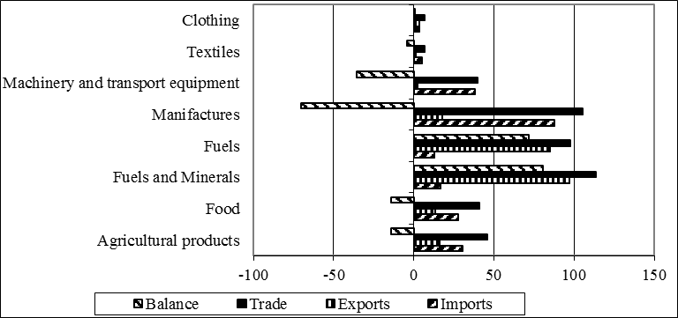
Figure 1. Trade of COMESA (2012, Billion USD)
Source: UNcomrade for WITS and own calculations.

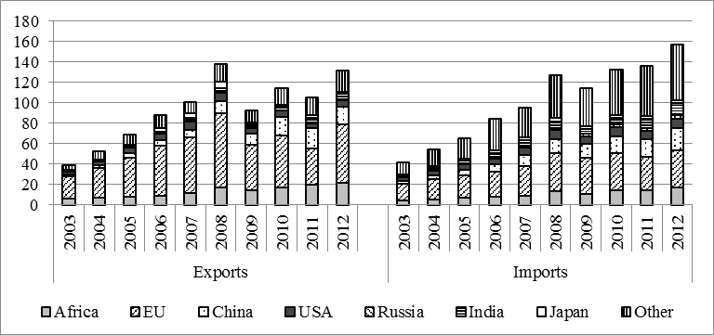
Figure 2. COMESA main trade partners (Billion USD)
Source: IMF DOTS and own calculations.

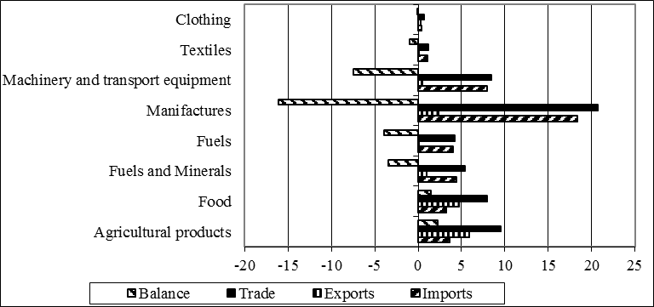
Figure 3. Trade of EAC (2012, Billion USD)
Source: UNcomrade for WITS and own calculations.

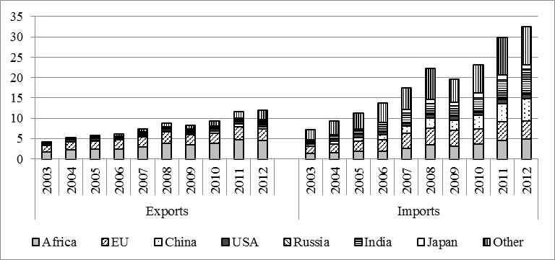
Figure 4. EAC main trade partners (Billion USD)
Source: IMF DOTS and own calculations.

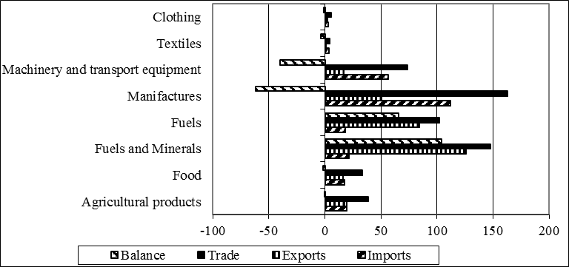
Figure 5. Trade of SADC (2012, Billion USD)
Source: UNcomrade for WITS and own calculations.

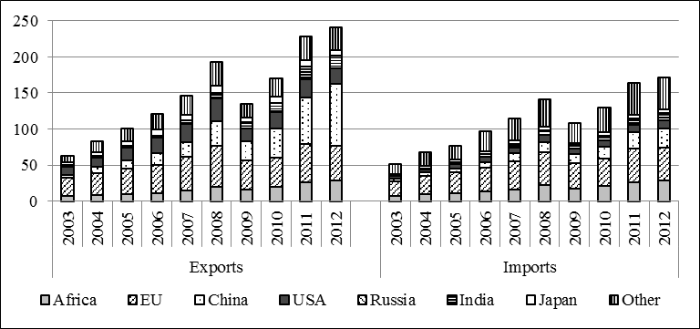
Figure 6. SADC main trade partners (Billion USD)
Source: IMF DOTS and own calculations.

