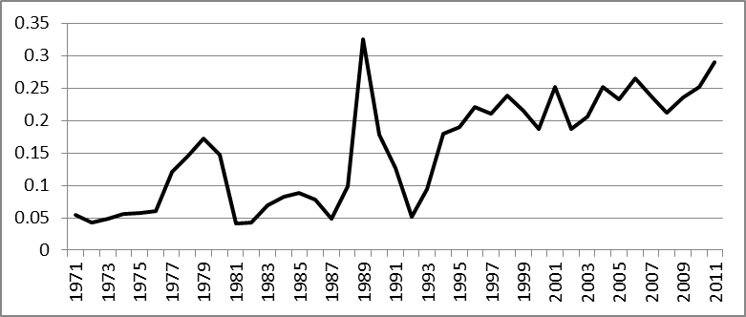
GRAPH 1. Natural gas intensity (cubic meter per Iranian Rials)

TABLE 1: Pre-revolution Era (1972-1978)
Residual | IE | SE | OE | TE | Period
0 | 24.7 | 2.37 | 37.02 | 64.09 | 1973-1974
0 | 67.36 | 43.18 | 136.98 | 247.51 | 1974-1975
0 | 82.13 | 32.15 | 145.57 | 259.85 | 1975-1976
0 | 93.74 | 9.13 | 172.40 | 275.27 | 1976-1977
0 | 389.51 | -14.74 | 192.6 | 567.37 | 1977-1978
0 | 657.43 | 72.1 | 684.6 | 1414.1 | 1972-1978
0 | 5.1 | 46.5 | 48.4 | Share in total effect (%)
Note. TE= Total change in natural gas consumption, OE= output effect, SE=structural effect, IE=[pure] intensity effect. All figures are in billion cubic meter. This note holds for the next Tables, too.

TABLE 2: Post-revolution Transitional and War Period (1979-1988)
Residual | IE | SE | OE | TE | Period
0.21 | 135.03 | 219.85 | -20.23 | 334.86 | 1978-1979
-1.4 | 435.27 | 31.45 | 417.17 | 882.51 | 1979-1980
72.53 | 262.72 | -1104.95 | 360.38 | -409.31 | 1980-1981
47.2 | 191.25 | -1017.89 | 320.17 | -459.29 | 1981-1982
7.7 | 97.04 | -628.70 | 186.16 | -337.84 | 1982-1983
-0.3 | -80.08 | -417.42 | 9.46 | -488.3 | 1983-1984
7.34 | -166.97 | -327.28 | -130.48 | -617.39 | 1984-1985
0.83 | -19.96 | -428.57 | -107.88 | -555.58 | 1985-1986
165.15 | 488.58 | -1265.13 | 582.59 | -28.81 | 1986-1987
53.8 | 655.95 | -542.25 | 577.3 | 744.78 | 1987-1988
353.02 | 1998.83 | -5480.9 | 2194.64 | -934.4 | 1978-1988
-37.9 | -213.9 | 586.6 | -234.8 | Share in total effect (%)

Table 3: Post-war Reconstruction Era (1989-1996)
Residual | IE | SE | OE | TE | Period
0 | -662.76 | -152.34 | 449.95 | -365.152 | 1989-1990
0 | -2576.49 | 1325.12 | 3112.29 | 1860.922 | 1990-1991
0 | -3888.19 | 1153.62 | 2894.25 | 159.6751 | 1991-1992
0 | -3361.67 | 1379.07 | 3383.78 | 1401.176 | 1992-1993
0 | -2226.22 | 1781.74 | 4595.53 | 4151.049 | 1993-1994
0 | -2115.94 | 2008.23 | 4705.95 | 4598.243 | 1994-1995
0 | -1684.17 | 1952.46 | 5460.82 | 5729.097 | 1995-1996
0 | -16515.43 | 9447.9 | 24602.6 | 17535.01 | 1989-1996
0 | -94.2 | 53.9 | 140.3 | Share in total effect (%)

Table 4: Reformist Cabinet (1997-2004)
Residual | IE | SE | OE | TE | Period
0 | 980.00 | 710.50 | -61.55 | 1628.95 | 1997-1998
0 | 150.04 | 1085.15 | 915.01 | 2150.20 | 1998-1999
0 | -825.63 | -256.29 | 805.92 | -276.00 | 1999-2000
0 | 1370.05 | -640.94 | 961.16 | 1690.26 | 2000-2001
0 | -931.90 | 377.04 | 1984.54 | 1429.68 | 2001-2002
0 | -183.60 | 482.18 | 2741.45 | 3040.02 | 2002-2003
0 | 1668.34 | 15.54 | 3730.14 | 5414.02 | 2003-2004
0 | 2227.30 | 1773.18 | 11076.7 | 15077.15 | 1997-2004
0 | 14.7 | 11.8 | 73.5 | Share in total effect (%)

Table 5: Hardliner Cabinet (2005-2011)
Residual | IE | SE | OE | TE | Period
0.73 | 1797.18 | -5.79 | 1123.74 | 2915.86 | 2005-2006
-36.88 | 340.23 | 1934.03 | 2551.87 | 4789.25 | 2006-2007
235.22 | -1602.42 | 2708.88 | 2717.69 | 4059.36 | 2007-2008
-42.32 | 237.18 | 3876.31 | 3556.29 | 7627.47 | 2008-2009
-110.51 | 1334.52 | 1625.18 | 4210.27 | 7059.45 | 2009-2010
332.45 | 3006.72 | -1796.27 | 4636.14 | 6179.04 | 2010-2011
378.69 | 5113.41 | 8342.34 | 18796 | 32630.44 | 2005-2011
1.1 | 15.7 | 25.6 | 57.6 | Share in total effect (%)

