**Supplementary**

**Cirebon as the Silk Road:**

**A New Approach of Heritage Tourism and Creative Economy**

Aan Jaelani

Shari’a and Islamic Economic Faculty IAIN Syekh Nurjati Cirebon

Jl. Perjuangan By Pass Sunyaragi Cirebon 45132

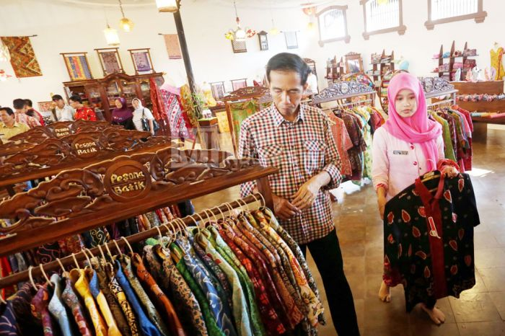

Figure 1. Mr Jokowi (President of the Republic of Indonesia) at Center “Batik” Cirebon

.

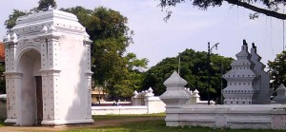

Figure 2. The Palace (Keraton) Kanoman Cirebon

.

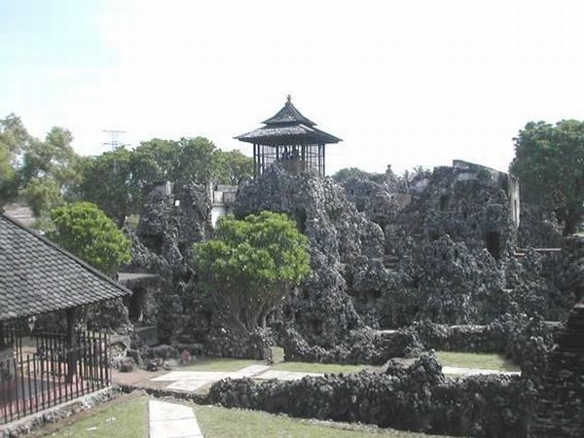

Picture 3. Sunyaragi’s Cave

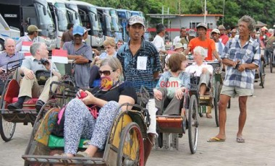

Figure 4. European tourists with rickshaw vehicles (Becak)

in the Market "Muludan" Cirebon

.

### [http://4.bp.blogspot.com/-RUgE7bAdi04/UdJrhrGvAuI/AAAAAAAABjI/xRE0aT8qgjw/s400/040920114644.jpg](http://4.bp.blogspot.com/-RUgE7bAdi04/UdJrhrGvAuI/AAAAAAAABjI/xRE0aT8qgjw/s320/040920114644.jpg)

**Figure 5. Pilgrims at the Tomb of Sunan Gunung Jati Cirebon**

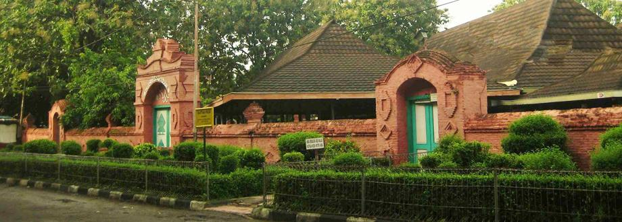

Figure 6. Mousque Agung Sang Cipta Rasa Kasepuhan Cirebon

[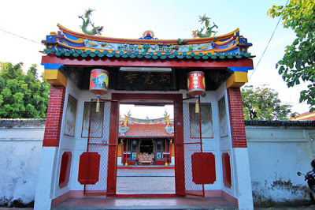](http://3.bp.blogspot.com/-FBFKshgtX8M/Ufanl7NdDCI/AAAAAAAABhE/DqFCtJRzvvw/s1600/1738.jpg)  
Figure 7. The Pagoda of Dewi Welas Asih Cirebon

[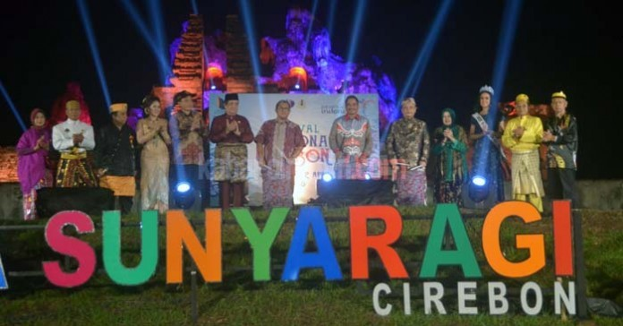](http://www.wonderfulcirebon.co.id/wp-content/uploads/2016/04/sunyaragi.jpg)

Figure 8. Cirebon Charm Festival 2016

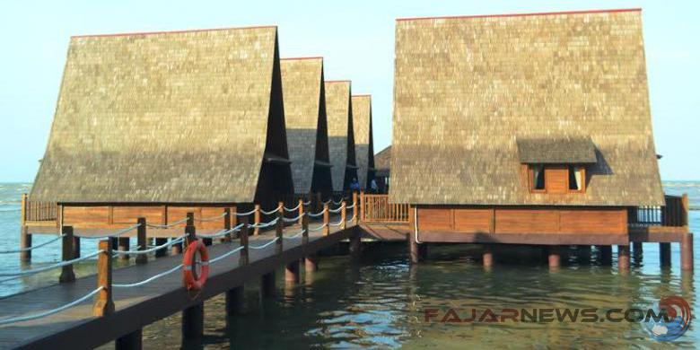

Figure 9. Cottage lodging facilities in Cirebon Waterland

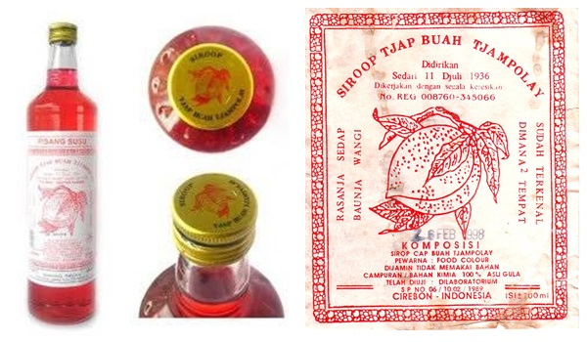

Figure 10. Syrup "Tjampolay" since 1936 in Cirebon

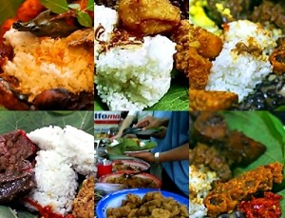

Figure 11. Rice “Jamblang”

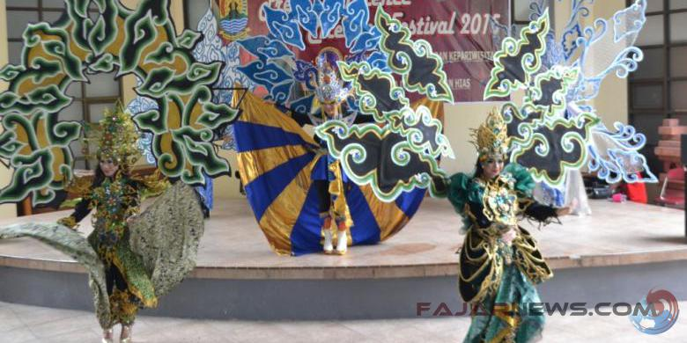

Figur 12. *Talent* in Fashion Carnival Cirebon 2015

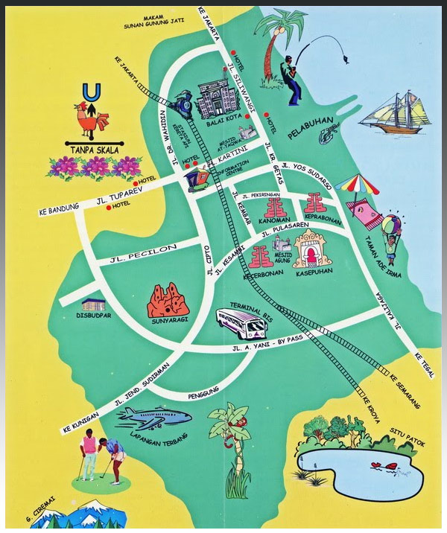

Figur 13. Cirebon Tourism Objects Material