Attitudes towards Privacy by Design in E-government: Views from the Trenches
(The Tables and Graphs Listed in the Manuscript)

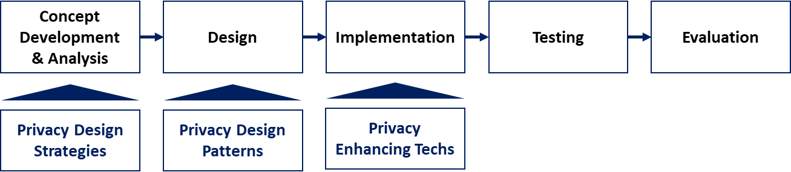
GRAPH 1: Software Development Life Cycle with Privacy Enhancement, Source: Hoepman, 2014

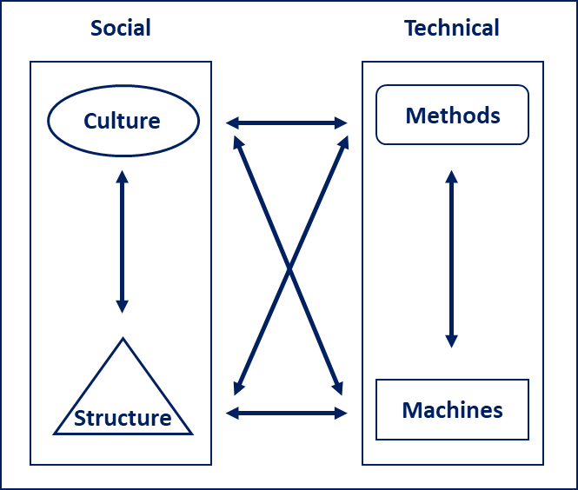
GRAPH 2: Socio-technical Model (STM), Source: Kowalski, 1994, p. 10

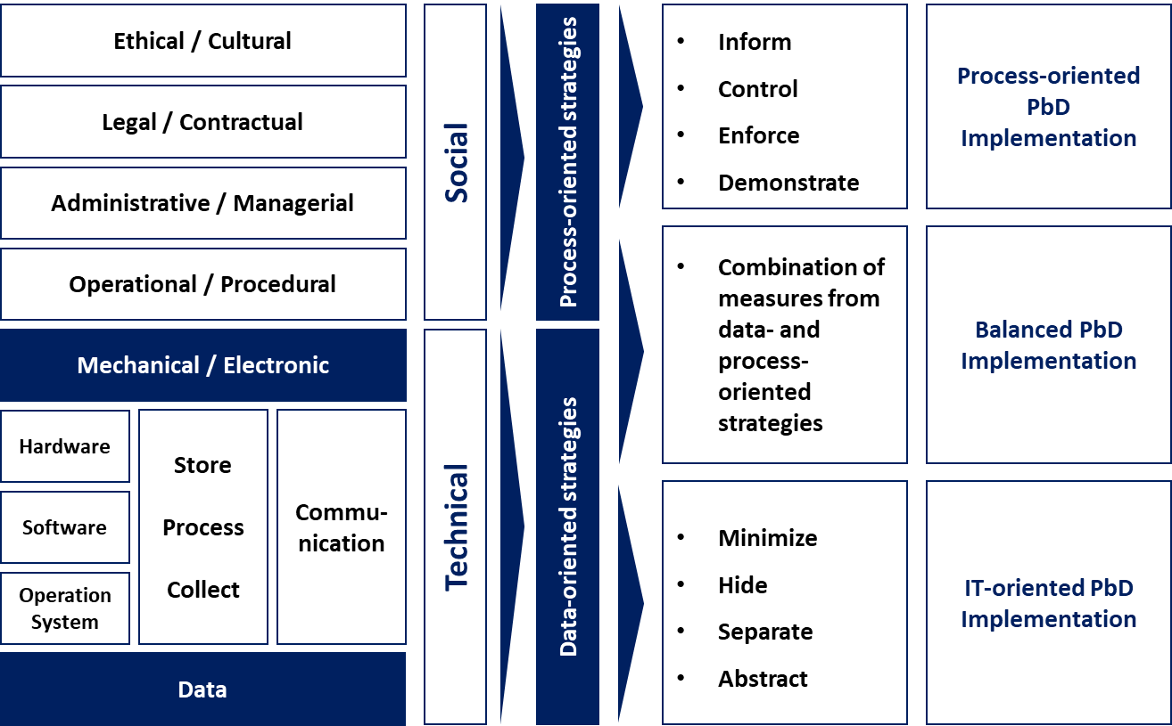
GRAPH 3: Mapping between Security by Consensus Model and Privacy-Enhancing Strategies, Source: Kowalski (1994), Hoepman (2014), mapping by author

TABLE 1: Thematic Analysis Results: Main themes, categories and initial codes
Themes | Categories | Total | Initial Codes | Mentions
The New Privacy Reality | Privacy Culture | 29 | New ways of thinking | 7
The New Privacy Reality | Privacy Culture | 29 | Educate public of the benefits | 6
The New Privacy Reality | Privacy Culture | 29 | Geopolitical differences | 5
The New Privacy Reality | Privacy Culture | 29 | Operational aspects | 4
The New Privacy Reality | Privacy Culture | 29 | High importance of data protection | 3
The New Privacy Reality | Privacy Culture | 29 | Are data needed? | 2
The New Privacy Reality | Privacy Culture | 29 | Difficulty of changing mentality | 1
The New Privacy Reality | Privacy Culture | 29 | Currency | 1
The New Privacy Reality | Privacy Enablers | 28 | Value of information | 5
The New Privacy Reality | Privacy Enablers | 28 | Personal space | 4
The New Privacy Reality | Privacy Enablers | 28 | Technical measures | 4
The New Privacy Reality | Privacy Enablers | 28 | Possible harm to people | 4
The New Privacy Reality | Privacy Enablers | 28 | State collects sensitive data | 3
The New Privacy Reality | Privacy Enablers | 28 | Protection from surveillance | 2
The New Privacy Reality | Privacy Enablers | 28 | Use existing solutions | 2
The New Privacy Reality | Privacy Enablers | 28 | Privacy ROI | 2
The New Privacy Reality | Privacy Enablers | 28 | Public sector accountability as driver | 1
The New Privacy Reality | Privacy Enablers | 28 | Possibility for wrong decisions | 1
The New Privacy Reality | Legal Obligations and Controls | 27 | Legal requirements | 18
The New Privacy Reality | Legal Obligations and Controls | 27 | Compliance checklist | 4
The New Privacy Reality | Legal Obligations and Controls | 27 | Need for legal changes | 3
The New Privacy Reality | Legal Obligations and Controls | 27 | Security checklists | 1
The New Privacy Reality | Legal Obligations and Controls | 27 | Sanctions not effective | 1
The New Privacy Reality | Risks and Potential Harm | 14 | Excessive surveillance | 4
The New Privacy Reality | Risks and Potential Harm | 14 | Human-related risks | 3
The New Privacy Reality | Risks and Potential Harm | 14 | Insight into consumers | 3
The New Privacy Reality | Risks and Potential Harm | 14 | Data compromise through social engineering | 2
The New Privacy Reality | Risks and Potential Harm | 14 | E-services delivered without data protection | 1
The New Privacy Reality | Risks and Potential Harm | 14 | Limited freedoms | 1
Current State-of-the-Art | Privacy-enhancing Processes | 41 | Preliminary security analysis | 9
Current State-of-the-Art | Privacy-enhancing Processes | 41 | New business processes for data protection | 7
Current State-of-the-Art | Privacy-enhancing Processes | 41 | Adherence to good practice | 7
Current State-of-the-Art | Privacy-enhancing Processes | 41 | Logging activity | 6
Current State-of-the-Art | Privacy-enhancing Processes | 41 | Need for stricter control on projects | 4
Current State-of-the-Art | Privacy-enhancing Processes | 41 | Organizational measures more important | 2
Current State-of-the-Art | Privacy-enhancing Processes | 41 | Auditing | 2
Current State-of-the-Art | Privacy-enhancing Processes | 41 | Need for detailed project requirements | 1
Current State-of-the-Art | Privacy-enhancing Processes | 41 | Need for data flow inventory | 1
Current State-of-the-Art | Privacy-enhancing Processes | 41 | Need for continuous improvement | 1
Current State-of-the-Art | Privacy-enhancing Processes | 41 | Physical security | 1
Current State-of-the-Art | Privacy-enhancing Technologies | 30 | Access controls | 11
Current State-of-the-Art | Privacy-enhancing Technologies | 30 | Encryption | 5
Current State-of-the-Art | Privacy-enhancing Technologies | 30 | Technical measures more important | 4
Current State-of-the-Art | Privacy-enhancing Technologies | 30 | Secure components | 3
Current State-of-the-Art | Privacy-enhancing Technologies | 30 | Data protection in transit | 3
Current State-of-the-Art | Privacy-enhancing Technologies | 30 | Authentication | 2
Current State-of-the-Art | Privacy-enhancing Technologies | 30 | Data protection at rest | 2
Implementation Challenges | Knowledge and Competences | 11 | Lack of understanding | 5
Implementation Challenges | Knowledge and Competences | 11 | Limited and expensive knowledge for PbD | 3
Implementation Challenges | Knowledge and Competences | 11 | Lack of knowledge in private sector | 3
Implementation Challenges | Privacy Barriers | 23 | Insufficient financial resources | 4
Implementation Challenges | Privacy Barriers | 23 | Legacy systems | 3
Implementation Challenges | Privacy Barriers | 23 | Technology limitations | 2
Implementation Challenges | Privacy Barriers | 23 | Trust issues | 2
Implementation Challenges | Privacy Barriers | 23 | No pressure from citizens | 2
Implementation Challenges | Privacy Barriers | 23 | Lack of clarity in regulations | 2
Implementation Challenges | Privacy Barriers | 23 | Limited understanding | 2
Implementation Challenges | Privacy Barriers | 23 | Problems with processes | 1
Implementation Challenges | Privacy Barriers | 23 | No PbD process | 1
Implementation Challenges | Privacy Barriers | 23 | No pressure from business | 1
Implementation Challenges | Privacy Barriers | 23 | Insufficient legal requirements | 1
Implementation Challenges | Privacy Barriers | 23 | Lack of concrete good practice | 1
Implementation Challenges | Privacy Barriers | 23 | Focus on material assets | 1
Implementation Challenges | Privacy Requirements | 21 | Need for administrative capacity | 7
Implementation Challenges | Privacy Requirements | 21 | Need for best practices | 5
Implementation Challenges | Privacy Requirements | 21 | Need for training | 2
Implementation Challenges | Privacy Requirements | 21 | Need for balanced approach | 2
Implementation Challenges | Privacy Requirements | 21 | Standards | 2
Implementation Challenges | Privacy Requirements | 21 | Need for IT solutions | 2
Implementation Challenges | Privacy Requirements | 21 | Need for high-level support | 1

