**Supplementary**

“Religious Heritage Tourism and Creative Economy in Cirebon:

The Diversity of Religious, Cultures and Culinaries”

Aan Jaelani, *et.al*

**Sunan Gunung Djati and The Sultanate Cirebon**

Name : Syarif Hidayatullah (Sunan Gunung Djati)

Reign : 1479-1568 M

Born : 1448 M (Cairo, Mamluk Sultanate of Egypt)

Died : 19 September 1568

Palace : Pakungwati Palace, Sultanate of Cirebon

Burial : Gunung Sembung cemetery, Gunung Jati, Cirebon.

Spouse : Nyai Ratu Dewi Pakungwati, Nyai Ratu Kawunganten,

Nyai Babadan, Nyai Ageng Tepasari, Nyai Lara Baghdad, Ong Tien Nio (Chinese)

Issue : Pangeran Sabakingking (Hasanuddin, Banten), Pangeran

Pasarean, Ratu Ayu, Ratu Winahon, Trusmi, Pangeran Bratakelana, Pangeran Jayalelana

Dynasty : Hashemite

Father : Syarif Abdullah of Egypt

Mother : Lara Santang (Princess Siliwangi, Padjajaran)

Religion : Sunni Islam

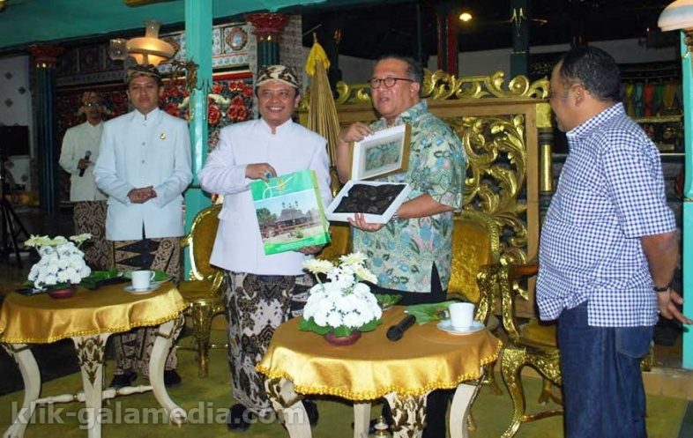

P.R.A. Arief Natadiningrat, The Sultanate of Kasepuhan Cirebon,

West Java, Indonesia (2016)

**The Types of Tourism and Creative Industries in Cirebon**

**1. Cultural tourism**

a. The Sultanete of Kasepuhan (Keraton Kesepuhan)

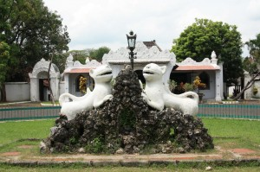

.

b. The Sultanete of Kanoman (Keraton Kanoman)

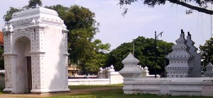

.

c. The Sultanete of Kacirebonan (Keraton Kacirebonan)

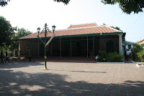

.

d. The Sultanete of Kaprabonan (Keraton Kaprabonan)

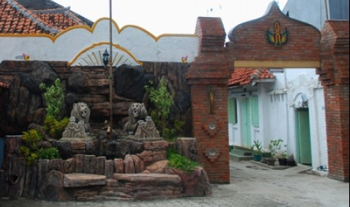

.

e. Cave Sunyaragi (Gua Sunyaragi)

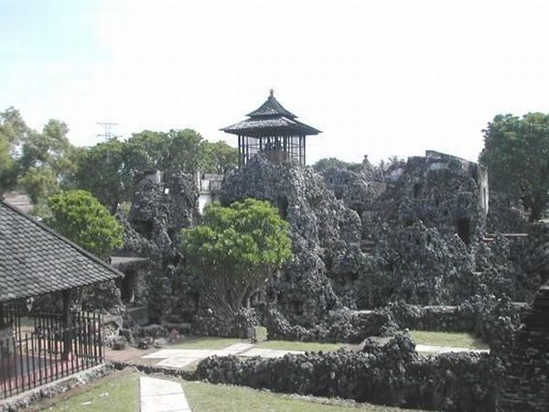

.

**2. Religious Tourism**

1. Pilgrim at Tomb Sunan Gunung Djati

### 

### [http://4.bp.blogspot.com/-RUgE7bAdi04/UdJrhrGvAuI/AAAAAAAABjI/xRE0aT8qgjw/s400/040920114644.jpg](http://4.bp.blogspot.com/-RUgE7bAdi04/UdJrhrGvAuI/AAAAAAAABjI/xRE0aT8qgjw/s320/040920114644.jpg)

Pilgrims praying before the tomb of Sunan Gunungjati

at Sunan Gunungjati cemetery site, Cirebon.

b. Mosque “Merah” Panjunan

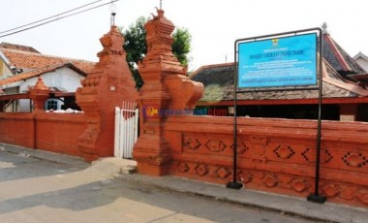

.

c. Mosque “Sang Cipta Rasa”, Kasepuhan

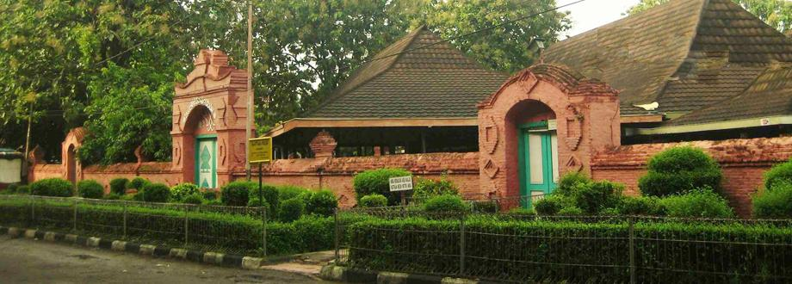

.

d. Pagoda, Kelenteng Dewi Welas Asih (Kelenteng Tiao Kak Sie)

[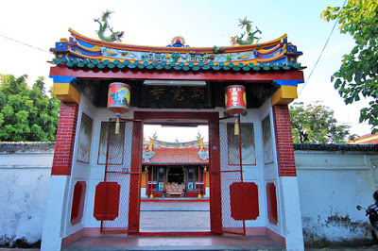](http://3.bp.blogspot.com/-FBFKshgtX8M/Ufanl7NdDCI/AAAAAAAABhE/DqFCtJRzvvw/s1600/1738.jpg)

**3. Culinary Tourism as Creative Economy**

a. Drinks “Sirop Tjampolay” (since 1936)

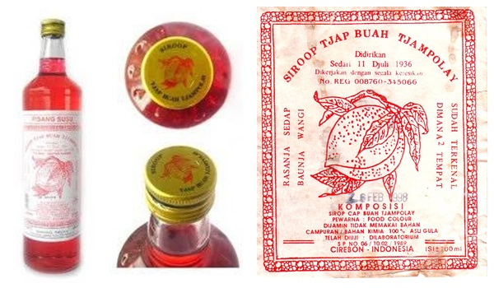

.

b. Rice “Sega/Nasi Jamblang”

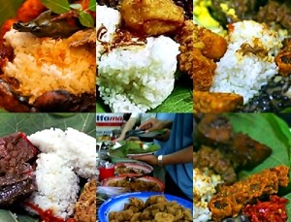

.

c. Empal Gentong/Empal Asem Amarta

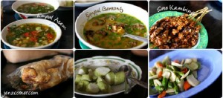

.

d. Rice “Nasi Lengko” and “Sate” Pagongan, Cirebon

[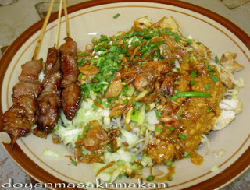](http://3.bp.blogspot.com/-HCeNO4j0BBM/UWdm5ZcL49I/AAAAAAAAAu0/fcsX14zzGJ4/s1600/dscn2934edit.jpg)

.

f. Fashion “Batik Trusmi” Cirebon

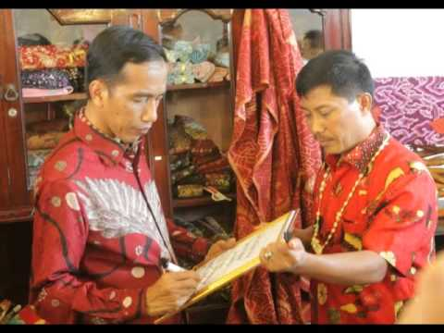

The President Republik Indonesia, Jokowi, at Pasar Batik Trusmi

[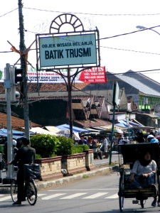](http://noem3d.files.wordpress.com/2009/06/wisata-belanja-batik-trusmi.jpg)

*(Source: http://www.disparbud.jabarprov.go.id)*