**Table 1:** Augmented Dickey-Fuller unit root test results.

|  |  |  |
| --- | --- | --- |
| Index returns | ADF Value | t-stat at 1% |
| MASI | -43,11*** | -3,43 |

***: values are statistically significant at levels 1%, 5%, and 10%

|  |  |
| --- | --- |
| Dependent variable | White statistic |
| MASI returns | 433,01*** |

**Table 2:** ARCH effect test results

***: values are statistically significant at levels 1%, 5% and 10%

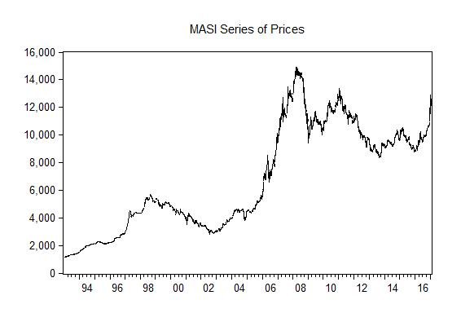

**GRAPH 1:** MASI’s series evolution of prices

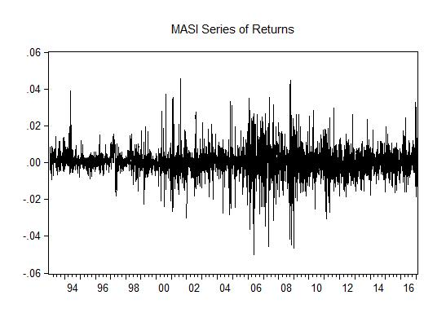

**GRAPH 2:** MASI’s series evolution of returns

|  |  |
| --- | --- |
| Dependent variable | Ljung Box Q(12) |
| MASI absolute returns series | 433,01*** |

**Table 3:** Ljung Box Q statistic test applied to absolute returns series

***: values are statistically significant at levels 1%, 5% and 10%

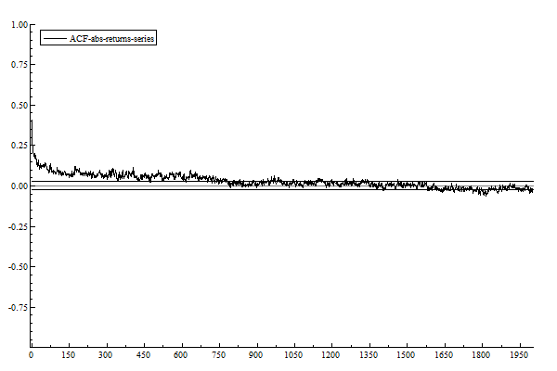The horizontal bands represent Bartlett’s formula for MA(q) 95% confidence intervals.

**GRAPH 3:** Plot of the autocorrelation function of the MASI absolute returns series.

**Table 4:** Descriptive statistics

|  |  |
| --- | --- |
| Descriptive statistics | MASI Returns |
| Mean | 0.000392 |
| Median | 0.000290 |
| Max | 0.045547 |
| Min | -0.050167 |
| Standard deviation | 0.006767 |
| Skewness | -0.086517 |
| Kurtosis | 10.30330 |
| Jarque-Bera | 1330.91 |
| P-value | 0.000000 |

***: values are statistically significant at levels 1%, 5%, and 10%

**Table 5:** model estimation results

|  |  |  |  |
| --- | --- | --- | --- |
| Model parameters | **GARCH(1,1)** | **IGARCH(1,1)** | **FIEGARCH** |
| Constant in mean | 0.000262*** | 0.000293*** | 0.0002545*** |
| Constant in variance | 1.38E-06*** | 1.527633*** | 0.0374628 |
| Alpha | 0.284154*** | 0.091386*** | -0.926871*** |
| Beta | 0.727950*** | 0.908614*** | 0.962261*** |
| Leverage | ------ | ------ | 0.645537*** |
| D | ------ | 1 | 0.690718*** |
| AIC | -7.674530 | -7.676671 | **-7.676739** |
| SIC | -7.658943 | -7.663319 | **-7.667100** |
| Log Likelihood | 23099.33 | 23013.82 | **23016.927** |

***: values are statistically significant at levels 1%, 5%, and 10%

**Table 6:** Wald test results

|  |  |
| --- | --- |
| Wald test x2 | P value |
| 0.925314 | 0.339 |