**TABLE 1:** *list of banks and their partners, who have obtained the authorization to open banks or participatory window*

|  |  |  |  |
| --- | --- | --- | --- |
| Bank | Partners | Partnership | Brand name |
| CIH Bank | Qatar International Islamic Bank and CDG | CIH holds 40% of the capital, QIIB 40% and CDG 20%. | Umnia Bank |
| BMCE Bank of Africa | Saudi / Bahrain group Dalla Al Baraka | BMCE holds 51% of the capital of the said subsidiary against 49% by ABG. | Bank Al Tamwil wal Inmaa |
| Banque Centrale Populaire | Guidance Financial Group. | BCP holds 80% against 20% for Guidance Financial Group. | Bank Al Yousr |
| Crédit Agricole du Maroc | the Islamic Development Corporation "ICD" | Crédit Agricole du Maroc owns 51% while ICD has a 49% share | Al Akhdar Bank |
| Attijariwafa Bank | Nan | transforming Dar Assafa into Bank Assafa | Bank Assafa. |
| BMCI | participatory windows | | Najmah |
| Crédit du Maroc | Arredah, |
| Société Générale | Dar Al Amane |

**TABLE 2:**  *Cross-Tabulation Murabaha Margin Profit Practice? * How do you consider the profit margin in the mourabaha product?*

|  |  |  |  |  |  |
| --- | --- | --- | --- | --- | --- |
|  | | How do you consider the profit margin in the mourabaha product | | Total | |
| Illicit | licit |
| Murabaha Margin Profit Practice | No | 19.06% | 01.65% | 20,72% | |
| Yes | 2.76% | 76.51% | 79,28% | |
| Total | | 21,82% | 78,18% | 100% | |
|  | Value | ddl | Asymptotic significance (bilateral) | Exact meaning (bilateral) | Exact meaning (unilateral) |
| Pearson chi-square | 273,073a | 1 | 0 |  |  |
| Correction for continuity | 267,909 | 1 | 0 |  |  |
| Likelihood ratio | 251,254 | 1 | 0 |  |  |
| Fisher's exact test |  |  |  | 0 | 0 |
| N° of observations | 362 |  |  |  |  |

at. 0 cells (0.0%) have a theoretical size less than 5. The minimum theoretical size is 16.37.

b. Calculated only for a 2x2 board

**TABLE 3**: *Cross Table In the case of an Islamic banking product more expensive than the classic? * How do you consider the profit margin in an Islamic product?*

|  |  |  |  |  |
| --- | --- | --- | --- | --- |
|  | | How do you consider the profit margin in an Islamic product | | Total |
| Illicit | Licit |
| In the case of an Islamic banking product more expensive than the classic | None | 0% | 0.55% | 0.55% |
| Conventional product | 12.43% | 2.76% | 15.19% |
| Islamic product | 9.39% | 74.86% | 84.25% |
| Total | | 21.82% | 78.18% | 100% |
|  | Value | ddl | Asymptotic significance (bilateral) | |
| Pearson chi-square | 136,970a | 2 | 0 | |
| Likelihood ratio | 114,45 | 2 | 0 | |
| N°of observations | 362 |  |  | |

at. 2 cells (33.3%) have a theoretical size of less than 5. The minimum theoretical strength is, 44.

**TABLE 4:**  *Cross-tabulation the absence of Islamic banking product as a constraint? * In the case of an Islamic banking product more expensive than the classical one?*

|  |  |  |  |  |  |
| --- | --- | --- | --- | --- | --- |
|  | | In the case of an Islamic banking product more expensive than the classical one | | | Total |
| None | Conventional product | Islamic product |
| Absence of Islamic banking product as a constraint | No | 0% | 3,59% | 1,66% | 5,25% |
| Yes | 0,55% | 11,60% | 82,60% | 94,75% |
| Total | | 0,55% | 55 | 305 | 362 |
|  | Value | ddl | Asymptotic significance (bilateral) | | |
| Pearson chi-square | 44,107a | 2 | 0 | | |
| Likelihood ratio | 29,801 | 2 | 0 | | |
| Phi | 0,349 |  | 0 | | |
| V of Cramer | 0,349 |  | 0 | | |
| N°of observations | 362 |  |  | | |

at. 3 cells (50.0%) have a theoretical size of less than 5. The minimum theoretical size is 10.

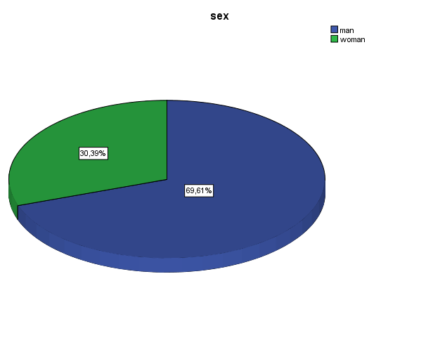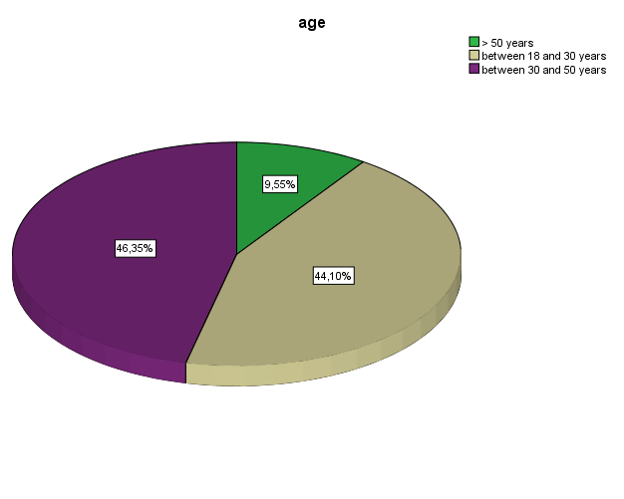

**GRAPH 1*:*** *sex and age*

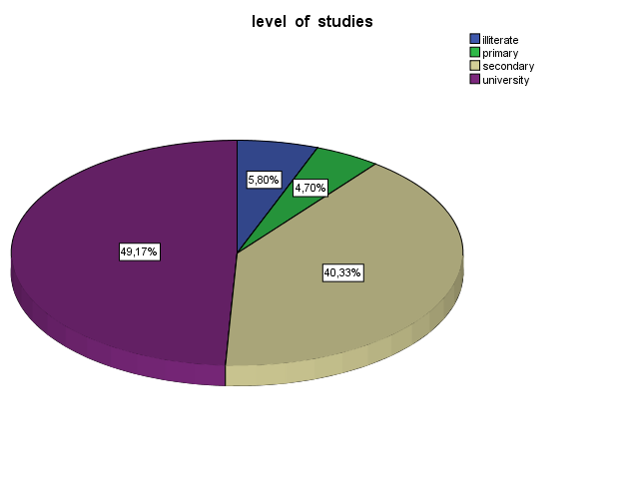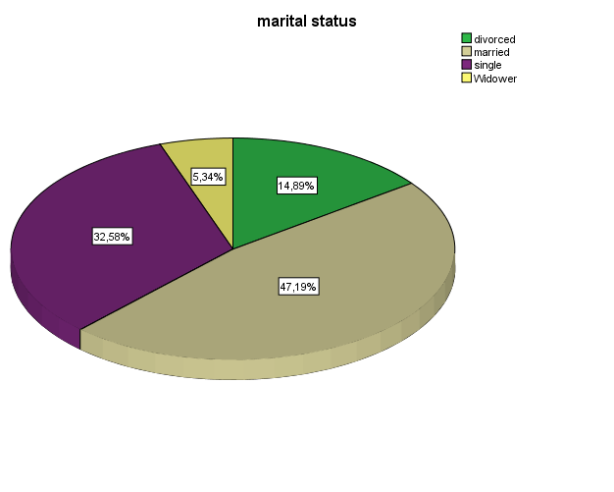

**GRAPH 2:** *level of education and marital status*

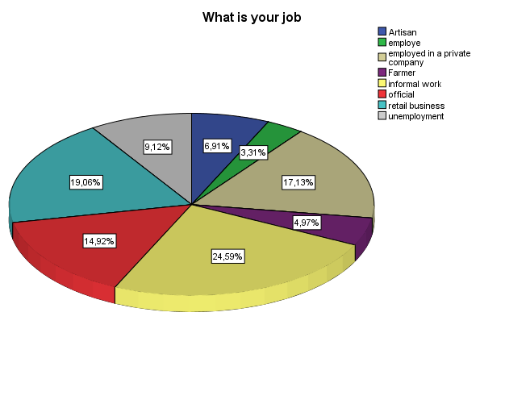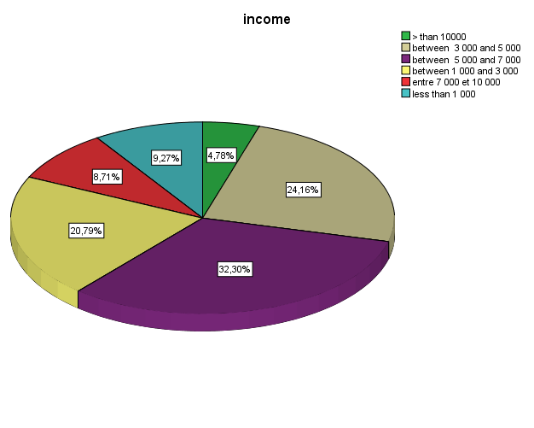

**GRAPH 3:** *Income and profession*