TABLE 1. Casablanca Stock Exchange Development
Year | N of Listed companies | Volume of trading | Number Of transactions | Market Capitalization In billion dirhams
Year | N of Listed companies | In billion dirhams | Number Of transactions | Market Capitalization In billion dirhams
2019 | 75 | 75 | 147993 | 626
2018 | 76 | 52 | 187015 | 582
2017 | 74 | 69 | 290548 | 625
2016 | 75 | 73 | 188 685 | 583
2015 | 75 | 52 | 130 477 | 453
2014 | 75 | 50 | 154 887 | 484.4
2013 | 75 | 62 | 125 243 | 451.1
2012 | 77 | 61 | 156984 | 445
2011 | 76 | 103 | 218970 | 516
2010 | 73 | 120 | 330 084 | 579
2009 | 77 | 72 | 285 460 | 508.9
2008 | 77 | 122 | 470 175 | 531.75
2007 | 73 | 359.7 | 468 953 | 586.3
2006 | 64 | 166.4 | 237 997 | 417.1
2005 | 54 | 148.5 | 160 444 | 252.3
2004 | 52 | 71.8 | 72 625 | 206.5
2003 | 52 | 53.7 | 38754 | 115.5
2002 | 55 | 22.4 | 37949 | 87.2
Source: compiled by the authors based on the CSE annual reports statistics.

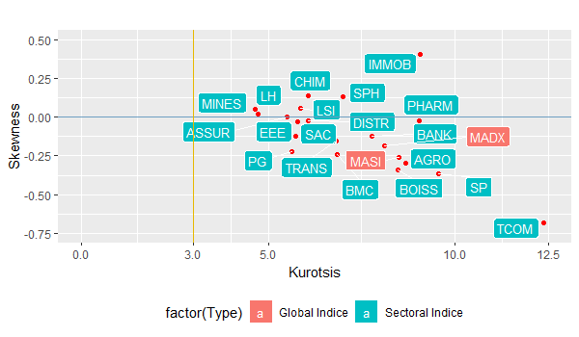
GRAPH 1. Skewness VS Kurtosis For Sectoral And Global Indices

TABLE 2. Descriptive Statistics
Sectors | Tickers | Start | #Daily Obs | Min | Mean | Max | SD
MADEX | MADX | 03/01/2002 | 4140 | -0.05 | 2.6e-04 | 0.05 | 0.008
Moroccan All Shares | MASI | 03/01/2002 | 4140 | -0.05 | 2.9e-04 | 0.04 | 0.007
Food Producer & Processors | AGRO | 03/01/2002 | 4140 | -0.09 | 4.50e-04 | 0.07 | 0.010
Insurance | ASSUR | 03/01/2002 | 4140 | -0.08 | 3.7e-04 | 0.07 | 0.014
Banks | BANK | 03/01/2002 | 4140 | -0.06 | 4.0e-04 | 0.05 | 0.010
Construction & Building Materials | BMC | 03/01/2002 | 4140 | -0.07 | 3.5e-04 | 0.07 | 0.013
Beverages | BOISS | 03/01/2002 | 4140 | -0.11 | 3.3e-04 | 0.06 | 0.015
Chemicals | CHIM | 03/01/2002 | 4140 | -0.15 | 1.1e-04 | 0.09 | 0.021
Distributors | DISTR | 03/01/2002 | 4140 | -0.07 | 4.4e-04 | 0.06 | 0.012
Electrical & Electronic Equipment | EEE | 03/01/2002 | 4140 | -0.10 | -5.2e-05 | 0.09 | 0.023
Real Estate | IMMOB | 03/01/2002 | 4140 | -0.07 | 1.0e-04 | 0.09 | 0.015
Leisures and Hotels | LH | 15/05/2006 | 3050 | -0.10 | -1.1e-04 | 0.09 | 0.024
Software & Computer Services | LSI | 03/01/2002 | 4140 | -0.06 | 8.1e-05 | 0.07 | 0.017
Mining | MINES | 03/01/2002 | 4139 | -0.07 | 2.3e-04 | 0.07 | 0.017
Oil & Gas | PG | 03/01/2002 | 4139 | -0.09 | 1.3e-04 | 0.06 | 0.016
Pharmaceutical Industry | PHARM | 06/03/2008 | 2503 | -0.06 | 2.8e-04 | 0.06 | 0.013
Utilities | SAC | 12/12/2006 | 2813 | -0.10 | 1.3e-04 | 0.09 | 0.020
Inves Companies & Other Finance | SFAF | 07/01/2002 | 4029 | -0.30 | 2.7e-04 | 0.31 | 0.012
Holding Companies | SPH | 07/01/2002 | 4041 | -0.11 | 6.8e-05 | 0.13 | 0.017
Paper & Forestry | SP | 03/01/2002 | 4139 | -0.37 | -4.8e-04 | 0.01 | 0.030
Telecommunications | TCOM | 16/12/2004 | 3401 | -0.10 | 1.7e-04 | 0.06 | 0.011
Transport | TRANS | 07/01/2002 | 4040 | -0.13 | 2.6e-04 | 0.08 | 0.018

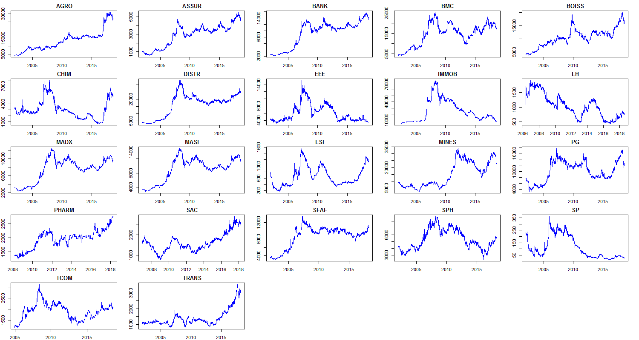
GRAPH 2. Historical Price Of Global And Sectoral Indices
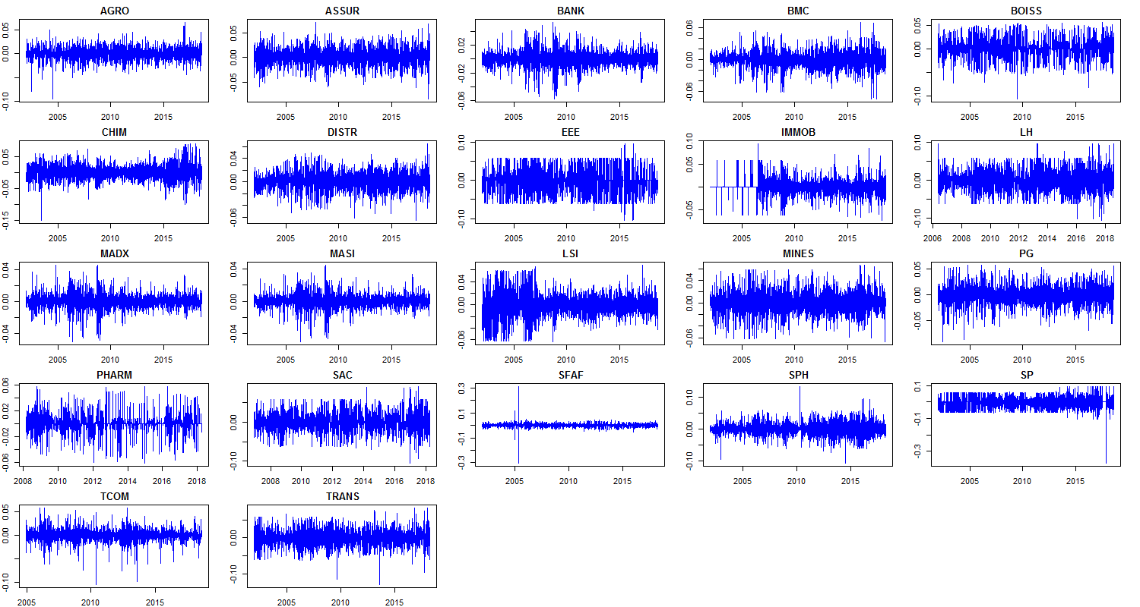
GRAPH 3. Returns Of Global And Sectoral Indices

Table 3. Tests of Stationarity
Indices | ADF | PP | KPSS
AGRO | -14.952*** | -4198.257*** | 0.103***
ASSUR | -14.611*** | -4250.232*** | 0.138***
BANK | -15.477*** | -3304.018*** | 0.434***
BMC | -14.458*** | -3847.695*** | 0.399***
BOISS | -15.197*** | -4010.844*** | 0.102 ***
CHIM | -14.877*** | -3827.335*** | 0.225***
DISTR | -14.887*** | -4321.892*** | 0.645***
EEE | -16.149*** | -3623.444*** | 0.154***
IMMOB | -13.255*** | -3370.082*** | 1.055 ***
LH | -14.736*** | -3068.897*** | 0.101***
MADX | -14.408*** | -2861.51*** | 0.336***
MASI | -14.346*** | -2863.157*** | 0.456***
LSI | -13.907*** | -3636.617*** | 0.254***
MINES | -14.279*** | -3572.408*** | 0.167***
PG | -14.484*** | -3661.186*** | 0.096***
PHARM | -14.561*** | -2434.891*** | 0.047***
SAC | -15.107*** | -2715.189*** | 0.227***
SFAF | -15.422*** | -4687.235*** | 0.352***
SPH | -15.177*** | -4558.539*** | 0.026***
SP | -15.821*** | -3943.132*** | 0.096***
TCOM | -13.937*** | -2969.679*** | 0.212***
TRANS | -16.728*** | -3955.80*** | 0.200***
***, **, *: significant at respectively 1%, 5% and 10% level

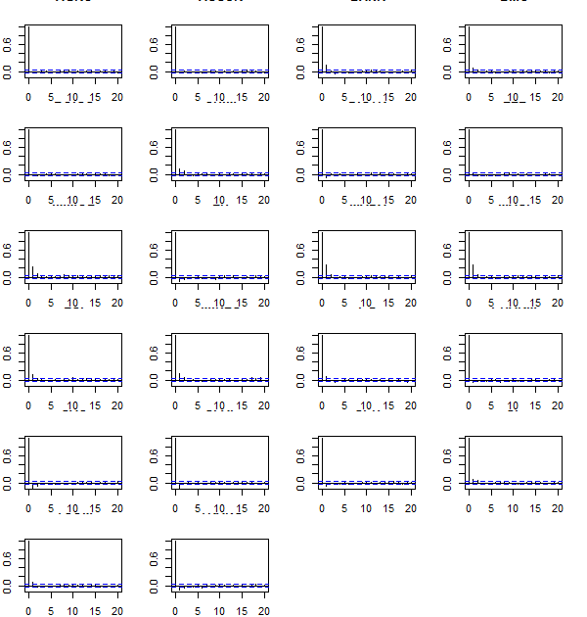
GRAPH 4. ACF Of Returns Of Global And Sectoral Indices
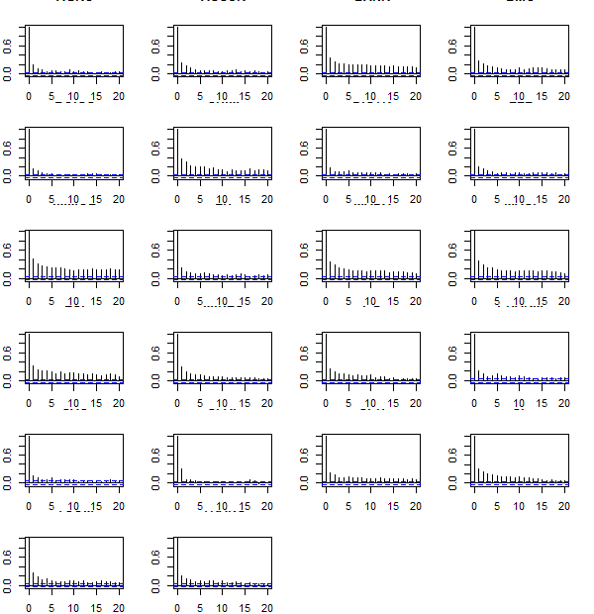

GRAPH 5. ACF Of Absolute Returns Of Global And Sectoral Indices

GRAPH 6. Long Run Autocorrelation Function Of Return Volatility For All Indices
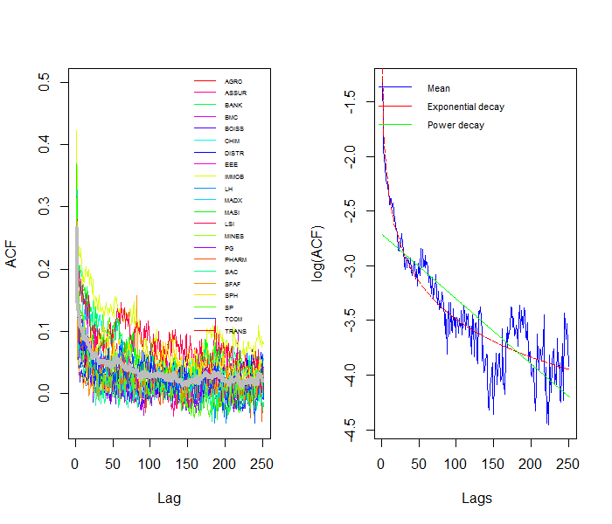
Note. On the left, the thin (wide) line represents individual (average) autocorrelation coefficient for return volatility for all indices- On the right: The average autocorrelation for each indice in blue and the fit from both exponential decay (in red), and power decay model (in green).

TABLE 4. GARCH Estimation
 | ω | α | β | α+β | HL | Uncond  Volatility
AGRO | 2.63e-05*** | 0.109*** | 0.651*** | 0.760 | 2.52 | 1.10e-04
ASSUR | 2.20e-05*** | 0.127*** | 0.766*** | 0.892 | 6.06 | 2.04e-04
BANK | 3.69e-06*** | 0.135*** | 0.823*** | 0.958 | 16.15 | 8.87e-05
BMC | 3.70e-06*** | 0.11*** | 0.872*** | 0.982 | 38.16 | 2.05e-04
BOISS | 3.42e-05*** | 0.107*** | 0.734*** | 0.841 | 4.00 | 2.15e-04
CHIM | 3.29e-05*** | 0.179*** | 0.745*** | 0.924 | 8.77 | 4.35e-04
DISTR | 1.19e-05*** | 0.093*** | 0.825*** | 0.918 | 8.10 | 1.45e-04
EEE | 7.02e-05*** | 0.123*** | 0.740*** | 0.863 | 4.70 | 5.11e-04
IMMOB | 3.54e-05*** | 0.335*** | 0.530*** | 0.865 | 4.78 | 2.61e-04
LH | 2.86e-05*** | 0.100*** | 0.852*** | 0.952 | 14.09 | 5.98e-04
MADX | 4.36e-06*** | 0.223*** | 0.717*** | 0.940 | 11.20 | 7.25e-05
MASI | 3.84e-06*** | 0.223*** | 0.714*** | 0.937 | 10.65 | 6.09e-05
LSI | 5.67e-06*** | 0.093*** | 0.886*** | 0.980 | 34.31 | 2.82e-04
MINES | 4.01e-05*** | 0.186*** | 0.678*** | 0.863 | 4.70 | 2.94e-04
PG | 3.36e-05*** | 0.155*** | 0.709*** | 0.864 | 4.74 | 2.47e-04
PHARM | 4.56e-05*** | 0.160*** | 0.559*** | 0.719 | 2.10 | 1.62e-04
SAC | 5.80e-05*** | 0.113*** | 0.745*** | 0.858 | 4.53 | 4.08e-04
SFAF | 6.73e-05 | 0.432 | 0.171 | 0.604 | 1.37 | 1.70e-04
SPH | 1.85e-05 | 0.114 | 0.824 | 0.938 | 10.83 | 2.98e-04
SP | 1.90e-04 | 0.176 | 0.61 | 0.787 | 2.89 | 8.89e-04
TCOM | 2.28e-05 | 0.203 | 0.64 | 0.842 | 4.03 | 1.45e-04
TRANS | 4.89e-05 | 0.127 | 0.719 | 0.846 | 4.14 | 3.18e-04
***, **, *: significant at respectively 1%, 5% and 10% level
TABLE 5. EGARCH Estimation
 | Omega | Alpha | Gamma | Beta
AGRO | -2.177*** | 0.224*** | 0.01 | 0.759***
ASSUR | -1.461*** | 0.29*** | -0.026*** | 0.826***
BANK | -0.471*** | 0.273*** | 0.015** | 0.949***
BMC | -0.401*** | 0.251*** | -0.008 | 0.952***
BOISS | -2.132*** | 0.273*** | 0.004 | 0.740***
CHIM | -1.189*** | 0.335*** | 0.047*** | 0.846***
DISTR | -0.707*** | 0.178*** | 0.009 | 0.918***
EEE | -1.630*** | 0.265*** | -0.015 | 0.778***
IMMOB | -2.124*** | 0.411*** | 0.016 | 0.747***
LH | -0.589*** | 0.205*** | -0.01 | 0.919***
MADX | -0.697*** | 0.375*** | -0.008 | 0.928***
MASI | -0.700*** | 0.367*** | -0.008 | 0.929***
LSI | -0.197*** | 0.198*** | -0.009 | 0.975***
MINES | -1.429*** | 0.366*** | -0.011 | 0.824***
PG | -1.153*** | 0.289*** | 0.000 | 0.860***
PHARM | -2.042*** | 0.242*** | -0.038*** | 0.760***
SAC | -1.525*** | 0.239*** | 0.014 | 0.800***
SFAF | -5.598*** | 0.571*** | 0.185*** | 0.372***
SPH | -0.863*** | 0.205*** | -0.042*** | 0.892***
SP | -2.376*** | 0.305*** | 0.009 | 0.659***
TCOM | -0.891*** | 0.257*** | -0.023*** | 0.898***
TRANS | -1.252*** | 0.237*** | 0.052*** | 0.841***
***, **, *: significant at respectively 1%, 5% and 10% level

TABLE 6. Estimation of fractional difference parameter
 | Hurst | ML | GPH | Sperio
AGRO | 3.26e-02*** | 5.78e-03*** | 7.62e-02*** | 3.87e-02***
ASSUR | 1.75e-02*** | 4.58e-05*** | 2.25e-01*** | 1.39e-01***
BANK | 2.03e-02*** | 7.83e-02*** | 1.27e-01 | 1.11e-01
BMC | 5.33e-02*** | 5.36e-02*** | 9.55e-02*** | 9.30e-02***
BOISS | -1.35e-02*** | 4.58e-05*** | -1.91e-02*** | 2.42e-02***
CHIM | 9.07e-02*** | 8.87e-02*** | 1.46e-01*** | 1.10e-01***
DISTR | 9.58e-03*** | 4.58e-05*** | 2.42e-01*** | 2.04e-01***
EEE | 3.98e-02*** | 4.58e-05*** | 1.53e-01*** | 4.71e-02***
IMMOB | 1.15e-01*** | 1.68e-01*** | 2.53e-01*** | 2.02e-01***
LH | 5.25e-02*** | 4.58e-05*** | 3.35e-02*** | 1.38e-02***
MADX | 7.10e-02*** | 1.90e-01*** | 1.16e-01*** | 9.19e-02***
MASI | 8.17e-02*** | 1.97e-01*** | 1.10e-01*** | 9.16e-02***
LSI | 8.63e-02*** | 9.49e-02*** | 2.41e-01*** | 2.07e-01***
MINES | 7.25e-02*** | 1.02e-01*** | 2.66e-01*** | 1.98e-01***
PG | 1.98e-02*** | 4.63e-02*** | 1.05e-01*** | 6.20e-02***
PHARM | -4.43e-02*** | 4.58e-05*** | -1.20e-01*** | -1.15e-01***
SAC | 1.49e-01*** | 4.58e-05*** | 7.80e-02*** | 3.25e-02***
SFAF | 1.34e-02*** | 4.58e-05*** | 1.06e-01*** | 9.54e-02***
SPH | -2.50e-02*** | 4.58e-05*** | -3.73e-01*** | -2.71e-01***
SP | 7.55e-02*** | 5.63e-02*** | 8.49e-02*** | 8.01e-02***
TCOM | 4.03e-03*** | 2.97e-02*** | 7.73e-03*** | 2.96e-02***
TRANS | 5.04e-02*** | 4.58e-05*** | 1.36e-01*** | 9.90e-02***
***, **, *: significant at respectively 1%, 5% and 10% level

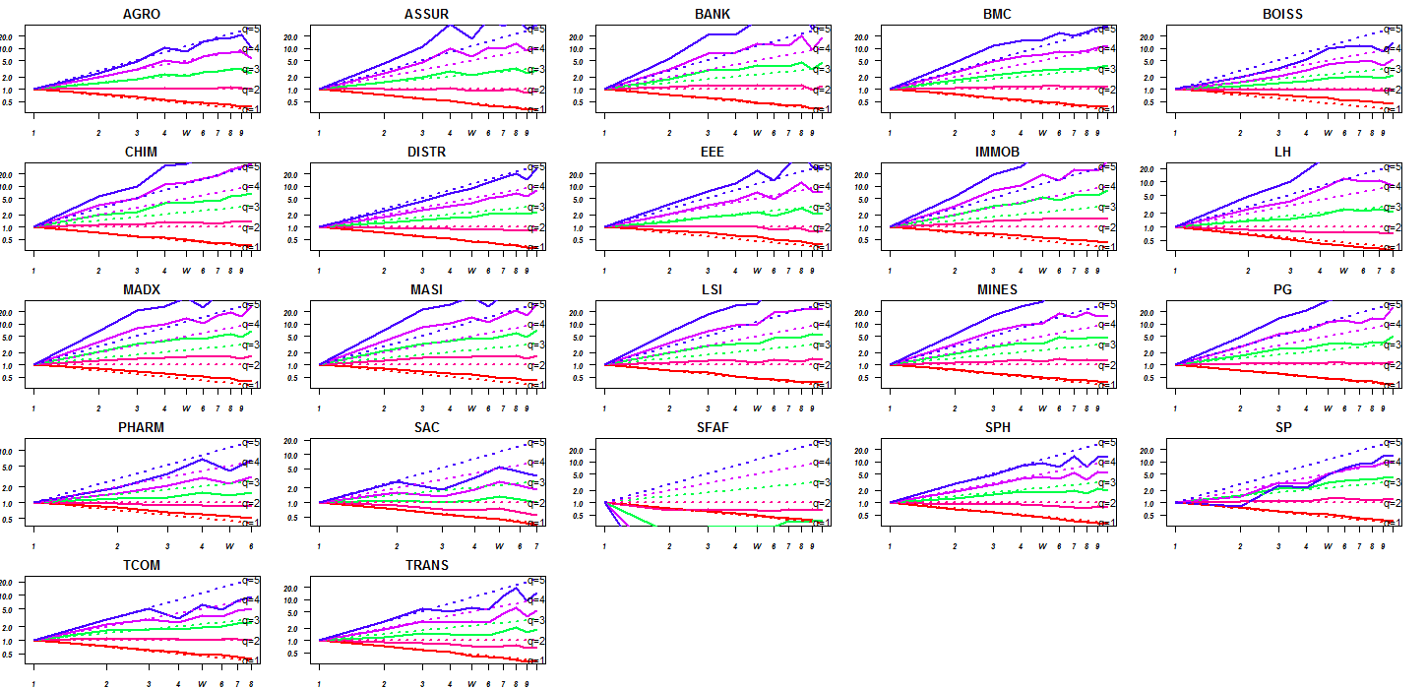
GRAPH 7. Partition function

GRAPH 8. complementary cumulative distribution functions of absolute returns
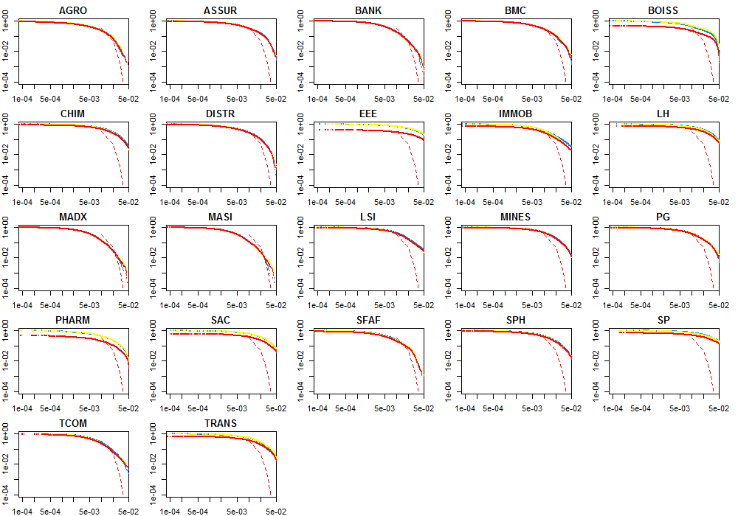
Notes: We present the complementary cumulative distribution function (ccdf) of the absolute value returns of sectoral and global indices (red line). The yellow and blue lines are instead the complementary cumulative distribution functions for negative and positive returns respectively. The red dashed line is the complementary cumulative distribution function of a gaussian with the same variance of the real return distribution.

Table 7.Omori Coefficients
Index | Date | Loss | SD | Real shock | p
 |  |  |  |  | Using Total number  of aftershocks | Using Number of negative  aftershocks
AGRO | 30/06/2004 | 0,0958 | 0,01 | 9,58 | 0,0513 | 0 ,0212
ASSUR | 28/06/2018 | 0,08436 | 0,014 | 6,03 | 0,4875 | 0,5045
ASSUR | 13/04/2017 | 0,06046 | 0,014 | 4,32 | 0,211 | 0,1027
BANK | 24/10/2008 | 0,05773 | 0,01 | 5,77 | 0,0296 | 0,0826
BMC | 23/03/2017 | 0,07374 | 0,013 | 5,67 | 0,0424 | 0,053
BOISS | 26/06/2009 | 0,1072 | 0,015 | 7,15 | 0,2697 | 0,012
CHIM | 06/06/2003 | 0,15132 | 0,021 | 7,21 | 0,2538 | 0,2866
DISTR | 13/04/2017 | 0,06556 | 0,012 | 5,46 | 0,2398 | 0,1289
EEE | 30/03/2016 | 0,10512 | 0,023 | 4,57 | 0,204 | 0,1499
IMMOB | 30/03/2018 | 0,07306 | 0,015 | 4,87 | 0,0773 | 0,1561
IMMOB | 30/03/2016 | 0,06693 | 0,015 | 4,46 | 0,1834 | 0,023
LH | 26/09/2017 | 0,10517 | 0,024 | 4,38 | 0,0493 | 0,0116
MADX | 19/05/2006 | 0,05094 | 0,008 | 6,37 | 0,25 | 0,4319
MASI | 19/05/2006 | 0,05017 | 0,007 | 7,17 | 0,2282 | 0,4319
LSI | 12/09/2008 | 0,06365 | 0,017 | 3,74 | 0,2073 | 0,176
MINES | 10/07/2018 | 0,06718 | 0,017 | 3,95 | 0,5367 | 0,6769
MINES | 17/03/2005 | 0,06161 | 0,017 | 3,62 | 0,0093 | 0,3135
PG | 20/06/2002 | 0,09074 | 0,016 | 5,67 | 0,0765 | 0,227
PHARM | 22/12/2014 | 0,06125 | 0,013 | 4,71 | 0,5136 | 0,3243
SAC | 26/12/2016 | 0,10518 | 0,02 | 5,26 | 0,265 | 0,2577
SFAF | 26/05/2005 | 0,30385 | 0,012 | 25,32 | 0,0716 | 0,0284
SPH | 01/07/2014 | 0,1072 | 0,017 | 6,31 | 0,1158 | 0,0303
SP | 15/11/2017 | 0,37475 | 0,03 | 12,49 | 0,3807 | 0,1687
SP | 06/03/2015 | 0,10555 | 0,03 | 3,52 | 0,3022 | 0,3792
TCOM | 21/05/2010 | 0,10504 | 0,011 | 9,55 | 0,3192 | 0,0716
TRANS | 19/08/2013 | 0,1309 | 0,018 | 7,27 | 0,2058 | 0,2899
Notes: The table shows the largest drop in each stock market index and the second largest fall in “ASSUR”, “IMMOB”, “MINES” and “SP”. Standard deviation and real shock are also presented in the table. The last two columns show the estimated values of parameter p in Eq. (11). P is computed at first when considering all aftershocks whether positive or negative, and second only for the negative shocks.
GRAPH 9. Cumulative number of aftershocks
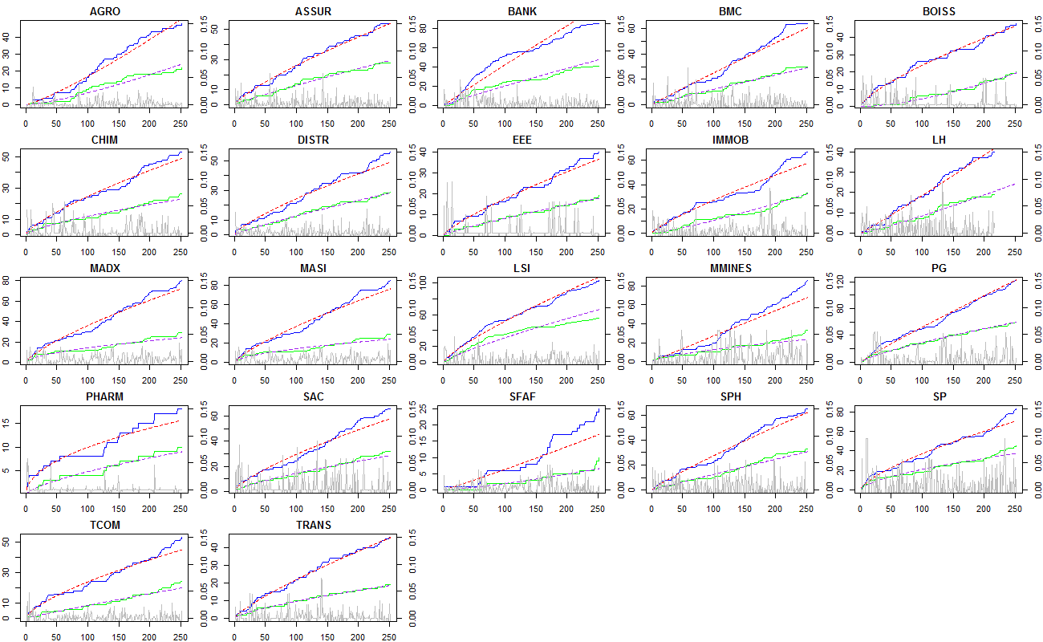
Notes: Absolute return (grey line) cumulative number of negative aftershocks (green line) and fit obtained based on Omori law

Results can be sent upon request.

