**The impact of age distribution on household**

**Consumption: Evidence from Saudi Arabia**



## Fig.1 Saudi Arabia: population growth (annual %) from 1960 to 20113 (in years)

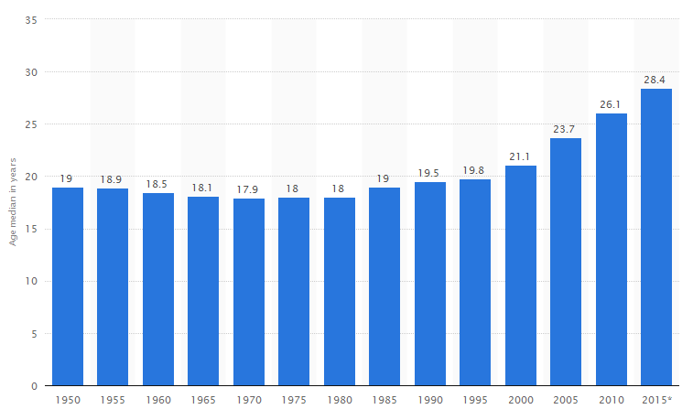

## Fig. 2. Saudi Arabia: Median age of the population from 1950 to 2015* (in years)

## Note: * 2015 is a prediction. Source: Statista 2014, ESCWA.

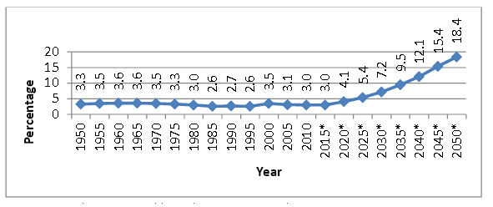

## Fig. 3 Saudi Arabia: proportion of elderly population between 1950 and 2050.

Note: Source: United Nations, World Population Prospects: The 2012 Revision and ESCWA.

* is a prediction.



Fig. 4. Saudi Arabia: household final consumption expenditure per capita (in thousands of Saudi Riyals (SR)) against subpopulations C1, C2 and C3 between 1970 and 2013.

Table 1. Augmented Dickey-Fuller Unit Root Tests

|  |  |  |  |  |  |  |
| --- | --- | --- | --- | --- | --- | --- |
| **Variables** | | **Test statistics** | **1% Critical value** | **5% Critical value** | **10% Critical value** | **p-value** |
| size | Age1 | -4.869 | -3.628 | -2.950 | -2.608 | 0.0000 |
| Age2 | 5.543 | -3.628 | -2.950 | -2.608 | 1.0000 |
| Age3 | 0.599 | -3.628 | -2.950 | -2.608 | 0.9876 |
| Proportion | Age1 | 7.657 | -3.628 | -2.950 | -2.608 | 1.0000 |
| Age2 | 6.933 | -3.628 | -2.950 | -2.608 | 1.0000 |
| Age3 | -1.542 | -3.628 | -2.950 | -2.608 | 0.5124 |
| HH Consumption expenditure per capita (C) | | 0.501 | -3.628 | -2.950 | -2.608 | 0.9849 |

Table 2. Vector Error Correction Model estimation of Eq. 10 for each age categories.

|  |  |  |  |  |  |
| --- | --- | --- | --- | --- | --- |
| Age category | | Explicative Variables | Coefficient | z | P>|z| |
| Age 1 | Size | *EC* | 0.0005942 | 0.06 | 0.956 |
|  | 0.7363724 | 6.10 | 0.000 |
|  | -1.12e-08 | -0.66 | 0.507 |
| Constant | 0.3499228 | 1.43 | 0.152 |
| Proportion | *EC* | -0.0746295 | -3.94 | 0.000 |
|  | 0.6567933 | 6.90 | 0.000 |
|  | 1.500183 | 3.02 | 0.03 |
| Constant | .0012888 | 0.01 | 0.994 |
| Age 2 | Size | *EC* | -0.0813686 | -2.62 | 0.009 |
|  | 0.7885722 | 7.89 | 0.000 |
|  | -9.05e-10 | -0.14 | 0.892 |
| Constant | 3.928819 | 2.61 | 0.009 |
| Proportion | *EC* | -0.0839044 | -3.56 | 0.000 |
|  | 0.7173383 | 7.56 | 0.000 |
|  | -0.9828395 | -2.24 | 0.025 |
| Constant | 0.0009282 | 0.01 | 0.996 |
| Age 3 | Size | *EC* | -0.0608272 | -2.52 | 0.012 |
|  | 0.7261081 | 6.82 | 0.000 |
|  | -1.77e-07 | -1.61 | 0.108 |
| Constant | 0.7913734 | 2.89 | 0.004 |
| Proportion | *EC* | 0.0078598 | 1.19 | 0.233 |
|  | 0.7036198 | 6.09 | 0.000 |
|  | -1.263843 | -0.77 | 0.440 |
| Constant | 0.0039446 | 0.02 | 0.985 |