## **Graph 1.** *Evolution of key policy rates*

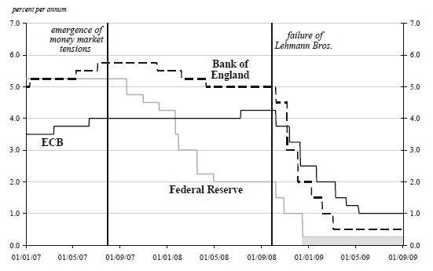

## **Source:**Lenza, M., Pill, H. & Reichlin, L. (2010), *Monetary Policy in exceptional times*, ECB Working Paper Series № 1253

## **Graph 2.** *Balance Sheets of advanced Central Banks*

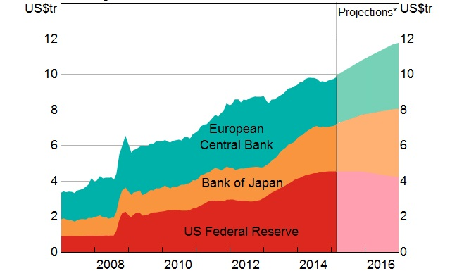

## **Source:** Bloomberg, RBA & Thomson Reuters

## **Note**: Based on central bank communicated intentions assuming constant exchange rates

## **Graph 3.** *Relation between Monetary policy and Financial Stability*C:\Users\User\Desktop\Monetary & Financial Stability.jpg

## **Source:** Bank of England, Financial Stability Report, № 33, June 2013

## **Table 1.** *Risks from MP-Plus and Mitigating Policies*

|  |  |  |  |
| --- | --- | --- | --- |
| MP- Plus Policy | Potential Risk | Risk Assessment | Mitigating Policies |
| Prolonged periods of low interest rates | Pressure on the profitability and solvency of financial institutions | Low | Robust capital requirements |
| Excessive Risk Taking (search for yield) | Low | Vigilant risk-based supervision, robust capital requirements |
| Ever greening, delay in balance sheet | Medium | Vigorous pursuit of balance sheet repair |
| Quantitative easing | Dependence on central bank financing | Medium | Improved liquidity risk management in banks, implementation of liquidity requirements, design of systemic liquidity risk mitigants |
| Indirect credit easing | Dependence on public sector financing | Medium | Improved liquidity risk management in banks, implementation of liquidity requirements, design of systemic liquidity risk mitigants |
| Distortion of allocation of credit, possibly weakening underwriting standards | Low | Vigilant risk-based supervision, dynamic forward-looking provisioning, robust capital requirements |
| Delay in balance sheet repair | Medium | Vigorous pursuit of balance sheet repair |
| Reinforcement of bank–sovereign links | Medium | Vigorous pursuit of balance sheet repair, robust capital requirements |
| Direct credit easing | Distortion in prices and market functioning | Low | Address associated market risks in banks |

## **Source:**IMF (2013, a), *Global Financial Stability Report: Old Risk, New Challenges*

## **Table 2.** *Central Banks that have introduced Negative Policy Rates*

|  |  |  |  |  |  |
| --- | --- | --- | --- | --- | --- |
| Country | Date negative rate first introduced | | Latest policy rates, basic points (March 2016) | | |
|  | | | Lending rate | Main policyrate | Deposit rate |
| Danish National Bank | | July 2012 to April 2014;September 2014 onwards | 5 | 0 | -65 |
| ECB | | June 2014 onwards | 25 | 0 | -40 |
| Swiss National Bank | | December 2014 | 50 | - | -75 |
| Swedish Riksbank | | February 2015 | 25 | -50 | -125 |
| Bank of Japan | | January 2016 | 10 | 0 | -10 |
| Hungarian National Bank | | March 2016 | 145 | 120 | -5 |

## **Source:** [Viñals](https://blog-imfdirect.imf.org/bloggers/jose-vinals/) J., [Gray](https://blog-imfdirect.imf.org/bloggers/simon-gray/) S. & [Eckhold](https://blog-imfdirect.imf.org/bloggers/kelly-eckhold/), K.(2016), [*The Broader View: The Positive Effects of Negative Nominal Interest Rates*](https://blog-imfdirect.imf.org/2016/04/10/the-broader-view-the-positive-effects-of-negative-nominal-interest-rates/), IMF Global Economy Forum

## **Table 3.** *Unconventional Central Bank Balance Sheet Policies*

|  |  |  |
| --- | --- | --- |
| Objective | Policy | Inclusion in the toolkit |
| Financial stability | Liquidity provision to funding and credit markets | Appropriate when liquidity stress spilling over into real economy but with safeguards and coordination |
| Foreign exchange liquidity provision to local markets | Appropriate when foreign exchange liquidity stress spilling over into real economy but with safeguards and coordination |
| Macroeconomic stability | Bond purchases | Effective for highly credible central banks to a degree when the policy rate is at the lower bound but there are risks and policy overlaps |
| Large-scale foreign exchange intervention | Effective for highly credible central banks in stemming appreciation in the short-run but also poses important policy, balance sheet, and multilateral risks |
| Credit provision to the private sector | Weak case to be done by the central bank vis-à-vis the government in all but the most exceptional circumstances |

**Source:** Stone, M., Fujita, K. & Ishi K. (2011), *Should Unconventional Balance Sheet Policies be added to the Central Bank Toolkit? A Review of the Experience So Far*, IMF Working Paper 11/145

## **Table 4.** *The relation between monetary and macro-prudential policies in various views*

|  |  |  |  |
| --- | --- | --- | --- |
|  | Modified Jackson Hole consensus | Leaning against the wind vindicated | Financial stability is price stability |
| Monetary Policy | Framework largely unchanged;  Limited effects on credit and risk taking;  Blunt instrument to deal with imbalances | Financial stability as secondary objective: lengthening of horizon; Affects risk-taking;  “Gets in all of the cracks” | Twin objectives on equal footing; Unblocks balance sheet impairments; avoids financial imbalances in upturns |
| Macro prudential | Granular and effective | Cannot fully address financial cycle; arbitrage | Indistinguishable from monetary policy |
| Interaction | Limited interaction and easy separation of objectives, instruments, … | Financial fragility affects monetary transmission are price stability Financial stability and price stability are intimately interlinked | Financial stability and price stability are intimately interlinked |

## **Source:**Smets, F. (2013), *Financial Stability and Monetary Policy: how closely interlinked?*, Sveriges Riksbank Economic Review, Special Issue