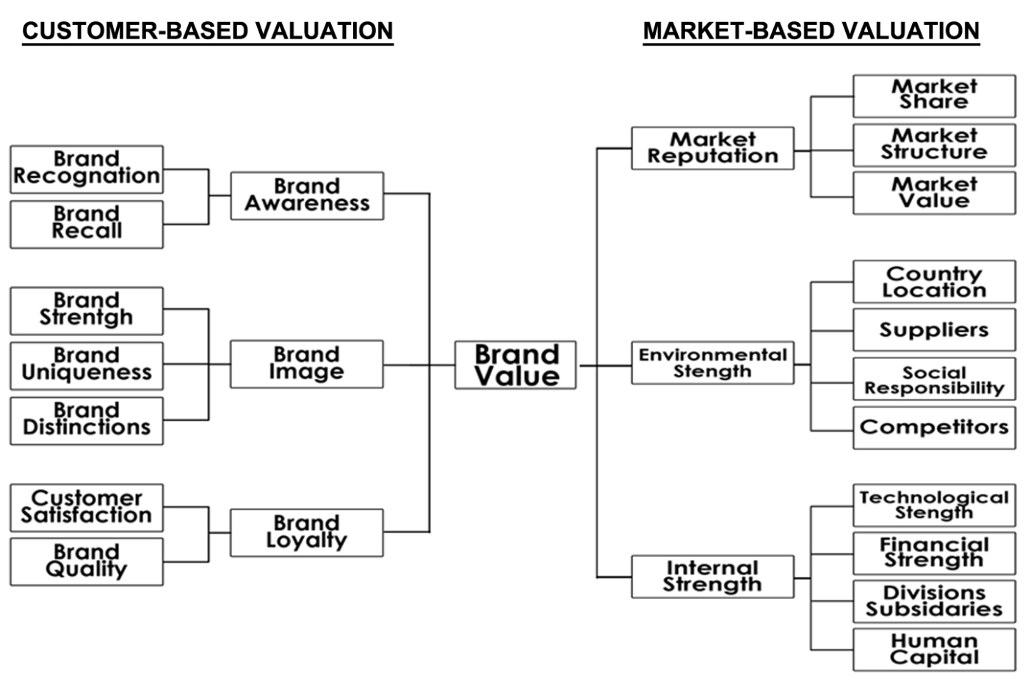

**Figure 1.** Customer- and Firm-Based Brand Valuation of Brand Value

**Source:** (Chieng Fayrene & Lee, 2011; Christodoulides & de Chernatony, 2010)

**Table 1.** Premium Production of Turkish Insurance Firms during 2005-2015 period (TL millions)

|  |  |  |  |  |  |  |  |  |  |  |  |  |
| --- | --- | --- | --- | --- | --- | --- | --- | --- | --- | --- | --- | --- |
|  | **COMPANY NAME** | **2005** | **2006** | **2007** | **2008** | **2009** | **2010** | **2011** | **2012** | **2013** | **2014** | **2015** |
| 1 | Ace European Group Ltd. | - | - | - | - | 3.78 | 22.23 | 24.43 | 36.92 | 56.50 | 60.12 | 94.72 |
| 2 | Acıbadem Sağlık ve Hayat Sigorta | 65.89 | 64.39 | 91.30 | 107.99 | 127.00 | 135.20 | 176.82 | 237.22 | 308.02 | 416.31 | 522.36 |
| 3 | Aegon Emeklilik ve Hayat | 13.03 | 10.66 | 9.30 | 7.48 | 7.26 | 14.35 | 29.93 | 55.55 | 89.23 | 133.86 | 195.62 |
| 4 | Aig (American Life) Hayat | 62.92 | 83.17 | 110.14 | 101.28 | - | - | - | - | - | - | - |
| 5 | AIG Sigorta | 94.84 | 121.91 | 154.40 | 186.37 | - | - | 199.69 | 217.52 | 275.78 | 300.30 | 342.28 |
| 6 | Ak Emeklilik | 54.81 | 61.32 | - | - | - | - | - | - | - | - | - |
| 7 | Aksigorta | 516.42 | 651.44 | 793.57 | 829.21 | 851.17 | 886.29 | 1,136.74 | 1,311.33 | 1,526.14 | 1,713.62 | 1,622.19 |
| 8 | Allianz Hayat ve Emeklilik | 89.27 | 87.90 | 82.46 | 78.60 | 77.75 | 74.85 | 84.03 | 91.04 | 99.89 | 109.55 | 115.50 |
| 9 | Allianz Sigorta | 636.34 | 765.04 | 860.81 | 905.22 | 930.69 | 995.78 | 1,129.04 | 1,444.88 | 3,199.13 | 3,216.18 | 4,050.87 |
| 10 | Allianz Yaşam ve Emeklilik | - | - | - | - | - | - | - | - | 244.06 | 337.09 | 440.71 |
| 11 | Anadolu Sigorta | 825.93 | 1,030.37 | 1,192.59 | 1,161.39 | 1,243.48 | 1,420.46 | 1,926.09 | 2,234.63 | 2,749.74 | 3,004.83 | 3,610.67 |
| 12 | Anadolu Hayat Emeklilik | 348.48 | 340.79 | 339.19 | 345.33 | 500.05 | 357.61 | 348.44 | 367.97 | 395.01 | 365.68 | 402.55 |
| 13 | Ankara Sigorta | 172.42 | 180.81 | 192.12 | 183.74 | 196.09 | 215.78 | 141.24 | 152.52 | 173.99 | 221.53 | 193.01 |
| 14 | Asya Emeklilik ve Hayat | - | - | - | - | - | - | - | - | 0.48 | 2.64 | 5.15 |
| 15 | Atradius Credit Insurance NV | - | - | 0.92 | 3.75 | 3.78 | 5.15 | 8.07 | 9.19 | 11.94 | 16.59 | 31.51 |
| 16 | Aviva Sigorta | 142.86 | 180.43 | 223.22 | 251.62 | 274.78 | 281.81 | 300.94 | 340.06 | 271.15 | 190.51 | - |
| 17 | AvivaSA Emeklilik ve Hayat | 157.06 | 131.47 | 79.92 | 150.51 | 154.92 | 155.31 | 148.42 | 197.54 | 232.89 | 258.31 | 263.46 |
| 18 | Axa (Oyak) Hayat ve Emeklilik | 113.26 | 127.22 | 140.85 | 123.61 | 108.62 | 56.65 | 54.84 | 62.63 | 99.02 | 36.24 | 23.02 |
| 19 | Axa (Oyak) Sigorta | 759.85 | 917.49 | 1,129.74 | 1,234.02 | 1,277.19 | 1,518.55 | 1,997.61 | 2,386.25 | 3,168.37 | 3,078.12 | 3,065.69 |
| 20 | Batı | -0.47 | 0.00 | 0.01 | 0.00 | - | - | - | - | - | - | - |
| 21 | BNP Paribas Cardif Emeklilik | - | - | - | - | - | - | 10.88 | 53.57 | 75.14 | 134.55 | 145.72 |
| 22 | BNP Paribas Cardif Hayat | - | - | 0.00 | 11.07 | 44.61 | 36.75 | 77.80 | 40.88 | 58.20 | 64.94 | 86.00 |
| 23 | BNP Paribas Cardif Sigorta | - | - | 0.00 | 0.30 | 11.51 | 15.99 | 11.27 | 11.14 | 22.26 | 27.57 | 61.51 |
| 24 | Chartis Sigorta | - | - | - | - | 174.45 | 173.59 | - | - | - | - | - |
| 25 | Cigna Finans Emeklilik ve Hayat | 161.30 | 206.57 | 0.97 | 47.90 | 48.78 | 85.49 | 124.68 | 161.12 | 202.00 | 209.95 | 254.14 |
| 26 | Cigna Hayat Sigorta | - | - | - | - | - | - | 0.22 | 0.27 | -0.02 | 0.00 | - |
| 27 | CIV Hayat Sigorta | - | - | 0.00 | 5.64 | 13.69 | 25.63 | 29.47 | 38.81 | 12.79 | -0.19 | 0.00 |
| 28 | Coface Sigorta | - | - | 7.11 | 16.20 | 11.98 | 17.87 | 23.80 | 32.21 | 48.92 | 59.32 | 71.16 |
| 29 | Demir Hayat Sigorta | 0.00 | 0.00 | 0.00 | 0.52 | 3.71 | 10.47 | 17.14 | 19.51 | 50.99 | 55.21 | 58.90 |
| 30 | Demir Sigorta | 20.85 | 28.84 | 32.87 | 37.28 | 41.95 | 52.00 | 50.25 | 59.02 | 28.73 | 31.28 | 41.05 |
| 31 | Deniz Hayat (Global Hayat) | 2.55 | 3.24 | 23.08 | 43.38 | 55.86 | 72.44 | - | - | - | - | - |
| 32 | Dubai Starr Sigorta | - | - | 0.00 | 0.61 | 75.81 | 128.02 | 115.65 | 70.77 | 80.03 | 124.65 | 162.96 |
| 33 | Ege (Euro) Sigorta | 4.88 | 4.46 | 4.37 | 12.84 | 57.64 | 58.89 | 100.33 | 176.85 | 205.31 | 246.47 | 198.76 |
| 34 | Ergo (İsviçre) Emeklilik ve Hayat | 62.44 | 64.67 | 61.43 | 42.68 | 23.34 | 26.06 | 24.03 | 21.99 | 13.27 | 8.50 | 7.55 |
| 35 | Ergo (İsviçre) Sigorta | 418.32 | 513.83 | 636.65 | 698.30 | 675.73 | 693.65 | 699.97 | 683.28 | 564.05 | 673.09 | 902.82 |
| 36 | Euler Hermes Sigorta | - | - | - | - | - | - | 11.75 | 25.16 | 35.38 | 51.21 | 65.02 |
| 37 | Eureko Sigorta AŞ (Garanti) | 298.44 | 357.79 | 415.47 | 478.52 | 539.18 | 618.40 | 709.04 | 685.40 | 789.08 | 801.15 | 1,002.55 |
| 38 | Fiba Emeklilik ve Hayat | - | - | - | - | - | - | - | - | 7.42 | 9.02 | 15.93 |
| 39 | Fortis Emeklilik ve Hayat | 17.62 | 25.86 | 19.37 | 28.65 | 23.66 | 19.62 | - | - | - | - | - |
| 40 | Garanti Emeklilik ve Hayat | 55.85 | 98.60 | 108.05 | 123.54 | 181.10 | 234.16 | 240.49 | 262.86 | 298.11 | 318.76 | 328.80 |
| 41 | Genel Yaşam | 64.67 | 82.24 | 111.08 | 125.69 | - | - | - | - | - | - | - |
| 42 | Generali Sigorta | 59.81 | 69.13 | 72.13 | 97.19 | 84.74 | 85.24 | 106.78 | 83.82 | 87.69 | 158.03 | 199.79 |
| 43 | Groupama Emeklilik (Başak) | 111.08 | 184.35 | 215.68 | 295.64 | 363.52 | 51.62 | 75.90 | 93.81 | 110.40 | 123.45 | 126.58 |
| 44 | Groupama Sigorta (Başak) | 374.68 | 434.09 | 467.99 | 524.46 | 726.68 | 693.87 | 818.26 | 826.80 | 975.76 | 1,057.75 | 1,114.56 |
| 45 | Güneş Sigorta | 446.80 | 495.44 | 638.14 | 709.62 | 727.07 | 737.37 | 819.95 | 922.46 | 1,076.72 | 1,212.63 | 1,288.39 |

**Table 1.** *(continues)*

|  |  |  |  |  |  |  |  |  |  |  |  |  |
| --- | --- | --- | --- | --- | --- | --- | --- | --- | --- | --- | --- | --- |
|  | **COMPANY NAME** | **2005** | **2006** | **2007** | **2008** | **2009** | **2010** | **2011** | **2012** | **2013** | **2014** | **2015** |
| 46 | Güven | 167.87 | 188.45 | 222.89 | 221.07 | - | - | - | - | - | - | - |
| 47 | Güven Hayat | 17.41 | 22.02 | 22.76 | 29.31 | - | - | - | - | - | - | - |
| 48 | Halk Hayat ve Emeklilik | 13.78 | 33.52 | 46.72 | 73.85 | 77.89 | 141.34 | 183.96 | 181.46 | 281.51 | 238.35 | 317.75 |
| 49 | Halk Sigorta | 66.59 | 108.07 | 113.62 | 105.71 | 113.35 | 155.69 | 206.50 | 395.16 | 470.36 | 537.82 | 757.37 |
| 50 | HDI Sigorta | 65.35 | 113.02 | 157.75 | 151.26 | 175.30 | 223.53 | 287.93 | 398.55 | 476.28 | 584.41 | 700.68 |
| 51 | Hür Sigorta | 34.28 | 46.50 | 42.05 | 46.24 | 52.87 | 52.80 | 50.09 | 57.02 | 43.93 | 20.90 | 2.29 |
| 52 | NN Hayat ve Emeklilik (ING) | - | - | - | - | 0.00 | 20.32 | 40.13 | 53.50 | 68.97 | 76.31 | 97.51 |
| 53 | Inter | 0.00 | 0.00 | 0.00 | 0.00 | - | - | - | - | - | - | - |
| 54 | Işık Sigorta | 61.85 | 81.97 | 105.49 | 109.36 | 112.35 | 118.24 | 138.05 | 165.66 | 184.07 | 164.44 | 157.93 |
| 55 | Katılım Emeklilik ve Hayat | - | - | - | - | - | - | - | - | 0.00 | 3.39 | 18.20 |
| 56 | Liberty Sigorta | - | - | 152.12 | 77.98 | 46.35 | 59.78 | 93.46 | 161.38 | 150.66 | 135.16 | 158.77 |
| 57 | Magdeburger | 0.00 | 0.00 | 0.00 | 0.00 | - | - | - | - | - | - | - |
| 58 | Mapfre Genel Sigorta | - | - | - | - | - | - | 557.79 | 886.59 | 1,352.89 | 1,490.95 | 2,110.57 |
| 59 | Mapfre Genel Yaşam Sigorta | 206.77 | 263.30 | 321.76 | 345.68 | 361.16 | 411.79 | 128.26 | 10.74 | 11.43 | 12.75 | 13.74 |
| 60 | Merkez | 0.00 | 0.00 | 0.00 | 0.00 | - | - | - | - | - | - | - |
| 61 | Metlife Emeklilik ve Hayat | - | - | - | - | 131.79 | 157.90 | 192.94 | 170.99 | 233.26 | 256.54 | 321.09 |
| 62 | Neova Sigorta | - | - | - | - | 0.26 | 61.80 | 84.93 | 131.14 | 256.80 | 380.33 | 514.43 |
| 63 | New Life Yaşam Sigorta | 0.00 | 0.00 | 3.40 | 5.84 | 6.02 | 3.36 | 0.82 | 0.47 | 0.51 | 0.33 | 0.20 |
| 64 | Orient Sigorta |  |  |  |  |  |  |  |  | 0.00 | 8.10 | 60.51 |
| 65 | Ray Sigorta | 200.75 | 254.27 | 270.99 | 274.20 | 253.83 | 252.37 | 254.41 | 302.95 | 354.30 | 380.03 | 444.64 |
| 66 | Rumeli | 0.00 | 0.00 | 0.00 | 0.00 | - | - | - | - | - | - | - |
| 67 | Rumeli Hayat Sigorta | 1.26 | 1.07 | 0.74 | 0.40 | 0.27 | 0.20 | 0.12 | 0.06 | 0.02 | 0.02 | 0.01 |
| 68 | SBN Sigorta (Şeker) | 87.22 | 131.37 | 3.63 | 58.32 | 84.95 | 109.93 | 68.71 | 60.99 | 83.94 | 100.52 | 125.26 |
| 69 | Sompo Japan Sigorta (Fiba) | - | - | 289.33 | 313.71 | 305.72 | 318.58 | 329.70 | 450.77 | 555.81 | 686.79 | 1,063.47 |
| 70 | SS Doğa Sigorta Kooperatifi | - | - | - | - | - | - | - | - | 0.00 | 26.48 | 291.33 |
| 71 | SS Koru Sigorta Kooperatifi | - | - | - | - | - | - | 2.09 | 29.66 | 33.93 | 29.51 | 95.26 |
| 72 | Teb | 73.32 | 113.91 | - | - | - | - | - | - | - | - | - |
| 73 | Ticaret | 6.07 | 0.00 | - | - | - | - | - | - | - | - | - |
| 74 | Turins Sigorta | - | - | - | - | - | - | - | - | 0.90 | 4.24 | 4.12 |
| 75 | Türk Nippon Sigorta | 0.03 | 0.00 | - | - | 4.19 | 21.11 | 35.93 | 30.39 | 44.11 | 71.89 | 110.34 |
| 76 | Türk P&I Sigorta | - | - | - | - | - | - | - | - | 0.00 | 7.20 | 13.87 |
| 77 | Vakıf Emeklilik | 74.97 | 86.10 | 81.63 | 63.45 | 68.87 | 92.99 | 141.27 | 173.25 | 225.60 | 185.54 | 243.65 |
| 78 | Unico Sigorta | - | - | - | - | - | - | - | - | - | - | 221.83 |
| 79 | Yapı Kredi | 469.74 | 574.34 | 628.14 | 631.54 | 607.98 | 758.17 | 973.10 | 1,227.38 | - | - | - |
| 80 | Yapı Kredi Emeklilik | 117.04 | 112.69 | 98.68 | 110.23 | 92.38 | 109.96 | 176.00 | 212.48 | - | - | - |
| 81 | Ziraat Hayat ve Emeklilik | - | - | - | - | 0.00 | 601.77 | 810.09 | 590.37 | 804.82 | 617.49 | 630.50 |
| 82 | Ziraat Sigorta | - | - | - | - | 0.00 | 172.59 | 318.46 | 378.78 | 567.63 | 703.21 | 932.35 |
| 83 | Zurich Sigorta | - | - | 154.84 | 185.92 | 216.11 | 231.23 | 316.34 | 341.95 | 384.33 | 438.02 | 506.69 |
|  | **TOTAL SECTOR** | **7,816.49** | **9,454.10** | **10,931.47** | **11,774.22** | **12,436.06** | **14,129.39** | **17,165.08** | **19,826.65** | **24,229.62** | **25,989.55** | **31,025.90** |

**Source:** (IAT[1], 2005-2015)

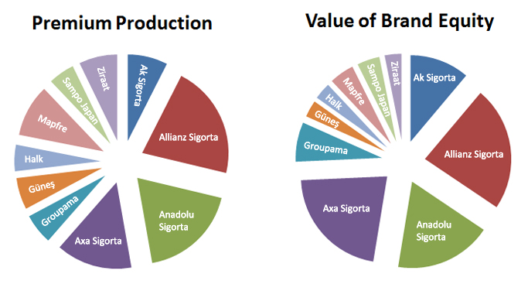

**Figure 2.** Premium Production and Value of Brand Equity of Top 10 Turkish Insurance Firms in 2015

**Source:** (IAT & Brand-Finance)

**Table 2.** Sample size of the study

|  |  |  |  |  |
| --- | --- | --- | --- | --- |
|  | **COMPANY NAME** |  |  | **COMPANY NAME** |
| 1 | Acıbadem Sağlık ve Hayat Sigorta AŞ |  | 17 | Garanti Emeklilik ve Hayat AŞ |
| 2 | Aegon Emeklilik ve Hayat AŞ |  | 18 | Generali Sigorta AŞ |
| 3 | AIG Sigorta AŞ |  | 19 | Groupama Sigorta AŞ (Başak) |
| 4 | Aksigorta AŞ |  | 20 | Gunes Sigorta AŞ |
| 5 | Allianz Sigorta AŞ (Koç) |  | 21 | Halk Sigorta AŞ |
| 6 | Anadolu Anonim Türk Sigorta Şirketi |  | 22 | HDI Sigorta AŞ |
| 7 | Ankara Sigorta AŞ |  | 23 | Işık Sigorta AŞ |
| 8 | Aviva Sigorta AŞ |  | 24 | Mapfre Genel Sigorta AŞ |
| 9 | Axa (Oyak) Sigorta AŞ |  | 25 | Ray Sigorta AŞ |
| 10 | BNP Paribas Cardif Sigorta AŞ |  | 26 | SBN (Şeker) Sigorta AŞ |
| 11 | Cigna Hayat Sigorta AŞ |  | 27 | Sompo Japan Sigorta AŞ (Fiba) |
| 12 | Demir Sigorta AŞ |  | 28 | Yapi Kredi Sigorta AŞ |
| 13 | Dubai Starr Sigorta AŞ |  | 29 | Vakıf Emeklilik Sigorta AŞ |
| 14 | Ege (Euro) Sigorta AŞ |  | 30 | Ziraat Sigorta AŞ |
| 15 | Ergo (İsviçre) Sigorta AŞ |  | 31 | Zurich Sigorta AŞ |
| 16 | Eureko Sigorta AŞ (Garanti) |  |  |  |

**Table 3.** Descriptive Statistics of Data

|  |  |  |  |  |  |  |  |  |
| --- | --- | --- | --- | --- | --- | --- | --- | --- |
|  | ***Mean*** | ***Median*** | ***Max.*** | ***Min.*** | ***Std. Dev.*** | ***Skewness*** | ***Kurtosis*** | ***N*** |
| **PP** | 548.45 | 281.71 | 4,607.09 | 0.97 | 698.58 | 2.73 | 12.09 | 320 |
| **BV** | 7,496.13 | 4,976.98 | 48,898.36 | 694.11 | 7,666.26 | 2.63 | 11.09 | 320 |
| **BT** | 79.12 | 82.50 | 97.50 | 47.50 | 10.60 | -0.69 | 2.95 | 320 |

**Notes:** PP and BV are presented in million TL. However, BT is transformed into numerical scale from letter rating grades by using methodology explained in Appendix-A.

**Table 4.** Results of Dynamic Panel GMM Analysis

|  |  |  |  |  |  |
| --- | --- | --- | --- | --- | --- |
| **Variable** | **Cross-section Specification** | | | |  |
| **Pooled** | **FE** | **RE** | **OD** | **FD** |
| PP(-1) | 0.8788**\*\*\***  (0.1539)  [5.7101] | 1.0530**\*\*\***  (0.4156)  [2.5334] | 0.8788**\*\*\***  (0.1539)  [5.7101] | 0.8485**\*\*\***  (0.0029)  [290.6894] | 0.8515**\*\*\***  (0.0055)  [155.8356] |
| BV | 0.0206**\*\***  (0.0101)  [2.0371] | 0.0084  (0.0265)  [0.3176] | 0.0206**\*\***  (0.0101)  [2.0371] | 0.0208**\*\*\***  (0.0000)  [366.6883] | 0.0208**\*\*\***  (0.0002)  [103.3887] |
| BT | 0.9644  (0.8408)  [1.1469] | 3.3081**\*\*\***  (0.8740)  [3.7849] | 0.9644  (0.8408)  [1.1469] | 5.3154**\*\*\***  (0.1443)  [36.8247] | 5.3497**\*\*\***  (0.1846)  [28.9859] |
| intercept | -96.1434**\***  (58.5515)  [-1.6420] | -291.2198**\*\*\***  (68.8748)  [-4.2282] | -96.1434**\***  (58.5515)  [-1.6420] | - | - |
| R-square | 0.9469 | 0.9603 | 0.9469'  0.9469" | 0.9873 | 0.9710 |
| J-statistics | 4.2184  (0.2388) | 2.3039  (0.5118) | 4.2184  (0.2388) | 29.2175  (0.4538) | 32.7110  (0.2895) |

**Notes:** Each column presents results for different effect-specified panel GMM analysis. All panels include 258 unbalanced observations structured by 31 cross-sections and 11 periods starting from 2005 up to 2015. Pooled panel does not have any effect specifications, whereas FE and RE have cross-sectional fixed and random effect specifications respectively considering static instruments of 2 lags of BV and BT as well as intercept. OD and FD models take into account orthogonal deviations and first-differences of cross-sections respectively considering Arellano-Bond type dynamic instruments of @dyn(pp,-2) @dyn(bv,-2) @dyn(bt,-2), i.e. all instruments have 2 lags. None of the panel models include period effect specifications. Coefficient standard errors and covariance have White characteristics with Arellano-Bond n-step GMM weighting matrix presented in parenthesis. As well as, computed t-statistics for each estimation are displayed in brackets. The diagnostics of each analysis is presented in the bottom part of the table where J-statistics are given with probability of rejection of the null hypothesis (overidentification) in the parenthesis. Two r-square values are shown in RE model where a single and double quotation indicate weighted and unweighted R-square values respectively.

**Figure 3.** Actual andFitted Values of Orthogonal Deviation (OD) transformed PP

**Notes:** The panel includes 258 unbalanced observations structured by 31 cross-sections and 11 periods from 2005 to 2015.

**Figure 4.** Actual andFitted Values of First Differenced (FD) transformed PP

**Notes:** The panel includes 258 unbalanced observations structured by 31 cross-sections and 11 periods from 2005 to 2015.



**Figure 5.** Actual andFitted Values of PP without any transformation

**Notes:** The panel includes 258 unbalanced observations structured by 31 cross-sections and 11 periods from 2005 to 2015.

**APPENDIX-A**

**Table 5.** Numerical Transformation of Letter Grade Ratings

|  |  |  |
| --- | --- | --- |
| **Brand-Finance Brand Trust Rating** | **Rating Description** | **My Numeric Transformation** |
| AAA+ | Prime | 100 |
| AAA | Prime | 97.5 |
| AAA- | Prime | 95 |
| AA+ | High grade | 92.5 |
| AA | High grade | 90 |
| AA- | High grade | 87.5 |
| A+ | Upper Medium grade | 85 |
| A | Upper Medium grade | 82.5 |
| A- | Upper Medium grade | 80 |
| BBB+ | Lower Medium grade | 75 |
| BBB | Lower Medium grade | 72.5 |
| BBB- | Lower Medium grade | 70 |
| BB+ | Speculative | 67.5 |
| BB | Speculative | 65 |
| BB- | Speculative | 62.5 |
| B+ | Highly Speculative | 60 |
| B | Highly Speculative | 57.5 |
| B- | Highly Speculative | 55 |
| CCC+ | Substantial Risks | 50 |
| CCC | Substantial Risks | 47.5 |
| CCC- | Substantial Risks | 45 |
| CC+ | Extremely Speculative | 42.5 |
| CC | Extremely Speculative | 40 |
| CC- | Extremely Speculative | 37.5 |
| C+ | Default Imminent | 35 |
| C | Default Imminent | 32.5 |
| C- | Default Imminent | 30 |
| D | In Default | 25 |

1. Insurance Association of Turkey (IAT): <http://engyeni.tsrsb.org.tr>